Final piece

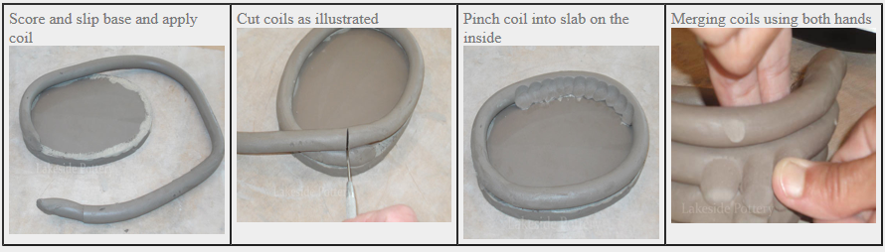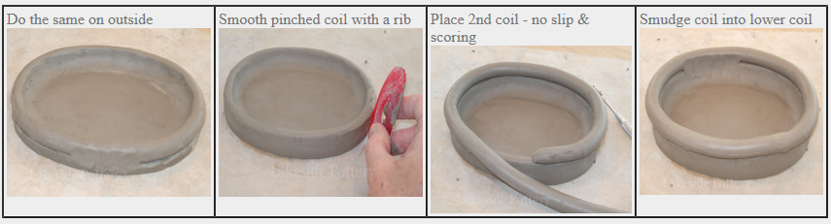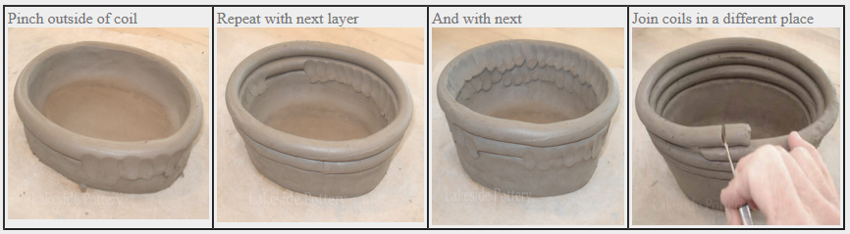

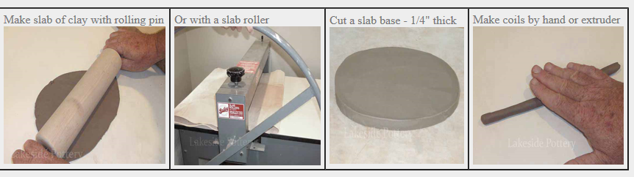

Paint Greek patterns on to the pots- look at Greek figures- Olympians are often depicted on pottery

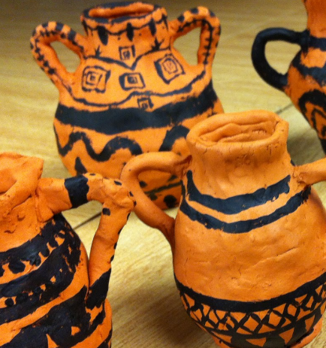

|  |  |
| --- | --- |
| **What will be taught through the unit:**   * **This history of clay and it’s impact** * **To use coils to build up and make a Greek pot** | |
| Art History | **Compare and contrast the works of Mackintosh to Ergotimos**   |  |  |  | | --- | --- | --- | | **Artist** | Ergotimos | Charles Rennie Mackintosh | | **Dates** | active in [Athens](https://en.wikipedia.org/wiki/Athens), *circa* 570–560 BC. | (1868 to 1928) | | **Info** | His son [Eucharios](https://en.wikipedia.org/w/index.php?title=Eucharios&action=edit&redlink=1) was also a potter, as was a grandson whose name is not known. | was a reformer of the excesses of the Art Nouveau style | | **Pottery** |  |  |   **The history of clay-link back to the Stone-age/Egyptians**  History of Clay. Throughout ancient history, clay has been used topically for soothing the skin, as well as internally for gastrointestinal issues. **Aristotle (384–322 BC)** made the first reference to the deliberate eating of earth, soil, or clay by humans (for therapeutic and religious purposes). |
| Art Appreciation-  Gallery Walk | Provide examples of pottery for the children to study  What clues are there that suggest the origins and period of pottery- what inspired the designs?  Look at how patterns tell a story- Greek pottery- Olympics  Chinese Willow pottery- watch a video https://www.bing.com/videos/search?q=willow+pottery&adlt=strict&view=detail&mid=09D200C3EB522F4751A409D200C3EB522F4751A4&&FOR |
| Skills burst | * Rolling coils of equal width- pressure of palms- Form the **clay** into sausage shapes, then roll into ropes 1/4 to 1/2 inches thick. * Pinching to join to coils * Smoothing with the thumb to join the two coils * Sponge small amounts onto the clay if it starts to become brittle/dry |
| Tools check |  |

Although called modelling tools, the triangular-headed varieties are also excellent trimming tools- these will help score out dimensions