Final Piece

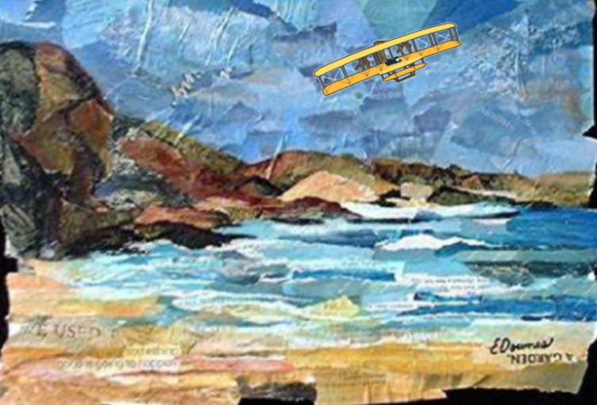

|  |  |
| --- | --- |
|  | |
| Art History | * Henri Rousseau was born in Laval in Mayenne, France on 21st May 1844. * Henri’s father was a plumber. * Rousseau went to high school in Laval, his home town. He was an average pupil, although he did very well in art and music lessons. * After he left school, Henri worked for a lawyer and then he joined the army, serving from 1863 to 1867. * His father died in 1868 and Henri Rousseau moved to Paris to take care of his mother. * He worked as a government official and then he became an import tax collector. * Rousseau married Clemence Boitard, the daughter of his landlord, and they had six children. Unfortunately, only one survived beyond childhood. Clemence died in 1888, and Rousseau married his second wife, Josephine Noury, in 1898. * Henri Rousseau only started painting seriously when he was in in his forties. * He was a self-taught painter and, as a result, his work is often described as naive or child-like. * Rousseau became a full-time artist at the age of 49. * He was an accomplished violin player, and he often supplemented his income by playing as a street musician. * Although some of Rousseau’s most well-known paintings are of jungle scenes, he never set foot in a jungle. Instead, he took his inspiration from the Jardin des Plantes (botanical gardens) in Paris and illustrations in books. |
| Art Appreciation-  Gallery Walk | See the source imageSee the source image  What can you see in the paintings?  What clues are there that these were painted a long time ago?  What types of flight can you see? |
| Skills burst | Investigate the blue colour palette- shades of colours- which shades would be used for the sky/water?  See the source image  Collage- shades of blue using the materials provided- wall paper, tissue paper, sugar paper  Add in a hot air balloon, zeplin or biplane. |