Final Piece

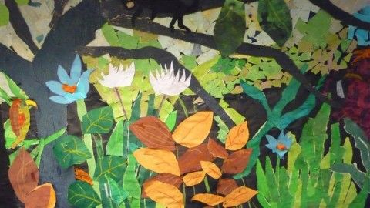

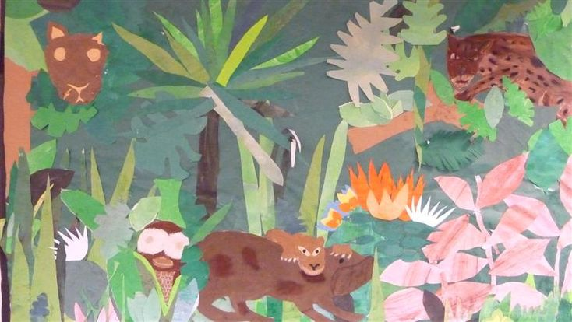

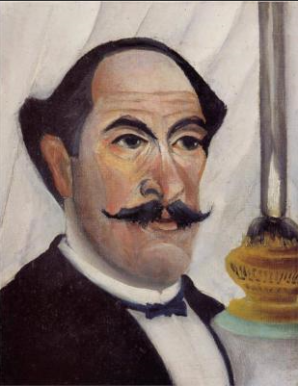

|  |  |
| --- | --- |
|  | |
| Art History | * Henri Rousseau was born in Laval in Mayenne, France on 21st May 1844. * Henri’s father was a plumber. * Rousseau went to high school in Laval, his home town. He was an average pupil, although he did very well in art and music lessons. * After he left school, Henri worked for a lawyer and then he joined the army, serving from 1863 to 1867. * Henri Rousseau only started painting seriously when * he was in in his forties. * He was a self-taught painter and, as a result, his work is * often described as naive or child-like. * Rousseau became a full-time artist at the age of 49. * He was an accomplished violin player, and he often supplemented his income by playing as a street musician. * Although some of Rousseau’s most well-known paintings are of jungle scenes, he never set foot in a jungle. Instead, he took his inspiration from the Jardin des Plantes (botanical gardens) in Paris and illustrations in books. |
| Art Appreciation-  Gallery Walk | **Whilst the poet and Rousseau champion Guillaume Appollinaire claimed**  **that the painter had vivid memories of tropical forests from military service**  **in Mexico, Rousseau admitted he had in fact never, ‘travelled further than**  **the glass houses of the Jardin des Plantes’. His jungle scenes were entirely**  **Parisian imaginings, assembled from observations of exotic plants in the**  **Jardin des Plantes (botanical gardens in Paris) hothouses, caged wild**  **animals in the Paris zoo or stuffed examples found in dioramas in the**  **Natural History Museum, illustrations in popular publications such as ‘Betes**  **Sauvage’, and oversized domestic plants and trees.** **The animals in the painting are also a mix of reality and imagination. A brown macaque, a kind of monkey, sits on a rock in a stream with a green bamboo like pole under his legs. To its right a row of lotus flowers leads back to two orange gibbon monkeys swinging through the trees. Rousseau added tails to these normally tailless animals. A black and white langur monkey sits on a branch, scratching his head and fishing with a pole. Another black monkey of indeterminate species sits on a branch peering at an enormous snake that slithers among the lotuses, perhaps posing a danger to the monkeys.**  **The monkeys depicted here inhabit various parts of Asia and Africa and could only come together in a book, zoo, or artist’s imagination.** |
| Skills burst | Layered techniques- background, middleground and foreground- what appear in all of these?  Practice layering leaves- using a range of shades of greens  Using different textured materials- crape paper, felt paper, foil paper |