Final Piece

Create a toy room with wallpaper print and drawn toys.

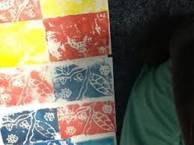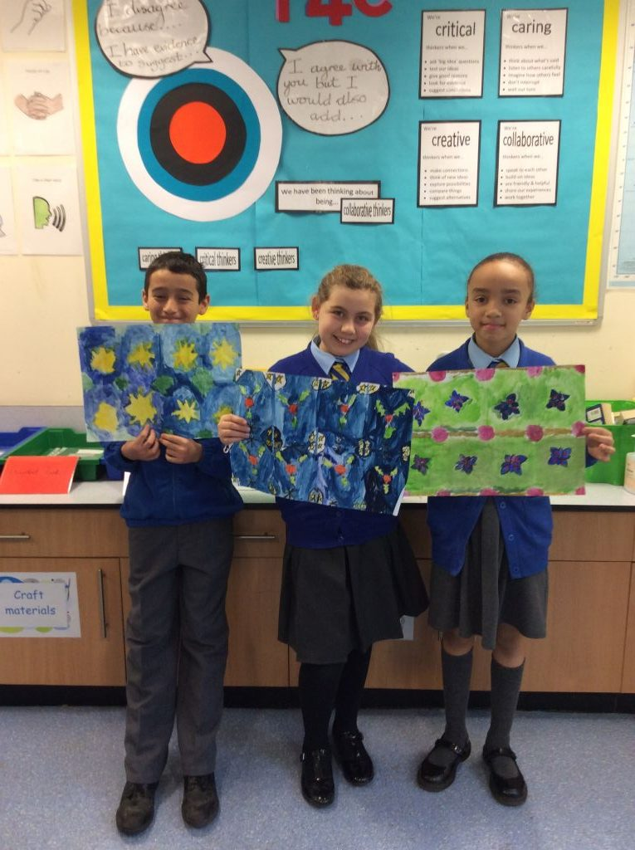

|  |  |
| --- | --- |
|  | |
| Art History | William Morris was born 24th March 1834 and died 3rd October 1896. Morris’ art focus was textiles. He made stained glass, patterned wallpaper and tapestries. He is most famous for his wallpapers. He created designs of floral patterns (patterns inspired by flowers and plants) which were repeated many times by block printing. The process was later improved through advances in technology, using printing machines and synthetic coloured inks. |
| Art Appreciation-  Gallery Walk | Windrush  Strawberry Theif  Tulip and Willow  Questions:  What is the pattern? Repeated pattern, half drop, full drop, random  How are they similar? Flowers, birds, small intricate detail in the background- larger images printed on top of the intricate details.  What colours are used? Dark colours- dark colours on the background-bright colours were used on the  How do you think they were made? Morris had his wallpapers printed by hand, using carved, pear woodblocks loaded with natural, mineral-based dyes, and pressed down with the aid of a foot-operated weight. Each design was made by carefully lining up and printing the woodblock motifs again and again to create a seamless repeat. |
| Skills burst | What is a pattern? How dis Morris use patterns? Can we duplicate pattern? Using a view finder to draw parts of the wallpaper/flowers.  Finish the flower symmetry – Use mirrors to complete the drawing of the simple pattern. Draw own flower/plant.  Design their pattern. – Carve into Styrofoam. Practice printing. Paint Styrofoam, press onto paper, roll over, peel off.  Explore different types of repeat patterning. Which do they prefer? Which will they use?  Create their pattern using paints and printing equipment.  Observational drawings of toys – what tools will they use? Choose equipment (pencils/pens) Pick one of the toys to draw for final piece.  Art Gallery – self review and peer review their final piece. |