<http://www.bbc.co.uk/history/ancient/romans/mosaics_gallery.shtml> - This site has a gallery of Roman mosaic images; <http://gwydir.demon.co.uk/jo/mosaic/info.htm#some> - This site has some great images with interesting associated facts; <http://www.rammtimetrail.org.uk/Roman-Mosaic> - This web page has an interactive, animated question-answer activity which is fun and informative; <http://primaryfacts.com/3577/roman-mosaics-facts-and-information> - This is a good information page; <http://en.wikipedia.org/wiki/Roman_mosaic> - Wikipedia page on Roman mosaics.

|  |  |
| --- | --- |
| **What will be taught through the unit:** | |
| Art History | **The history of Mosaics-** A mosaic is a piece of art or image made from the assembling of small pieces of coloured glass, stone, or other materials. It is often used in decorative art or as interior decoration. Most mosaics are made of small, flat, roughly square, pieces of stone or glass of different colours, known as tesserae. Some, especially floor mosaics, are made of small rounded pieces of stone, and called "pebble mosaics".  Roman mosaics were popular in public buildings and homes, and many examples can still be seen today. Mosaics were made from **hundreds of small pieces (or tesserae) of coloured stones and gems** put together to make a picture. *Where have mosaics been found? On the walls and floors of Roman buildings like bath houses and in private homes called villas.* *Why did rich Romans want to have mosaics made? May need to remind them of their trip to the museum. Why are Roman mosaics of such interest to historians?*  Draw out that it is because from the mosaics we learn all kinds of things about the Romans and their way of life, e.g. their food, fashions, beliefs, weapons, homes, sports, transport. *They are a great source of evidence from the past.* *How can we research mosaics?* *By using books and the internet.* Look together at the Wikipedia link below and click on the Ulysses image. Encourage the children to think like historians. *What can you learn about the Romans from this mosaic? Think about the ship, design, sails, rigging, oars, the clothes, and the god like/ mythical figure on the right with the bird legs and wings that seems to be bringing a storm.* Discuss the historical possibilities.  Local materials were often used to make mosaics. Sandstone would produce yellow, orange and red mosaics whilst chalk and limestone were used for white and Purbeck marble for grey or blue. |
| Art Appreciation-  Gallery Walk | Display a range of Mosaics around the room. Sonia King, Peter Mason, Maurice Bennett, Antoni Guadi, Roman Mosiacs  *What can you learn about the Romans from this mosaic?*  *We can learn about their way of life- what transport looked like, what fashion, what weapons they used etc.*  *Pick one and investigate as a table using the Ipads.* |
| Skills burst | Show the children lots of examples of mosaics- model making a design-  Make a Roman mosaic on line- Print out <http://www.gwydir.demon.co.uk/jo/mosaic/mkmosaic.htm-> <https://www.learningplayground.co.uk/mosaic/>    On squared paper investigate and design repeated patterns |
| Tools check | * Using the board- lay out the main pattern/object in the middle with the tiles. * Stick the tiles down * Fill in the surrounding pattern and boarder * Once the tiles are in place grout over the gaps- creating a smooth finish * Create small coaster mosaic and out them together to create a group mosaic. |

Final piece

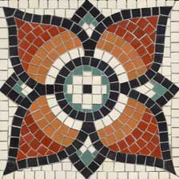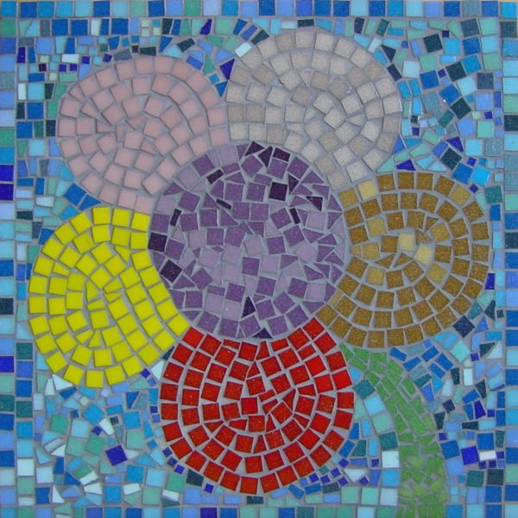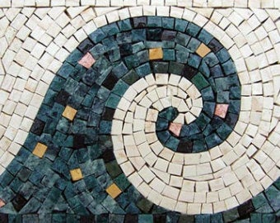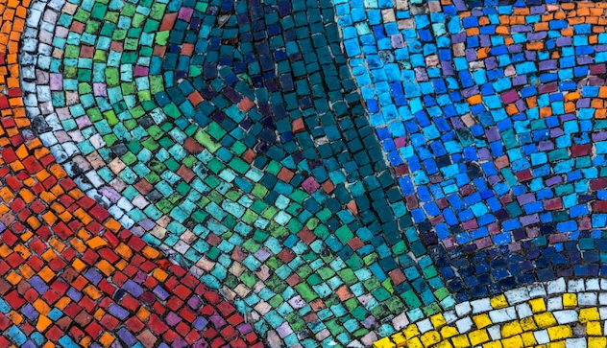

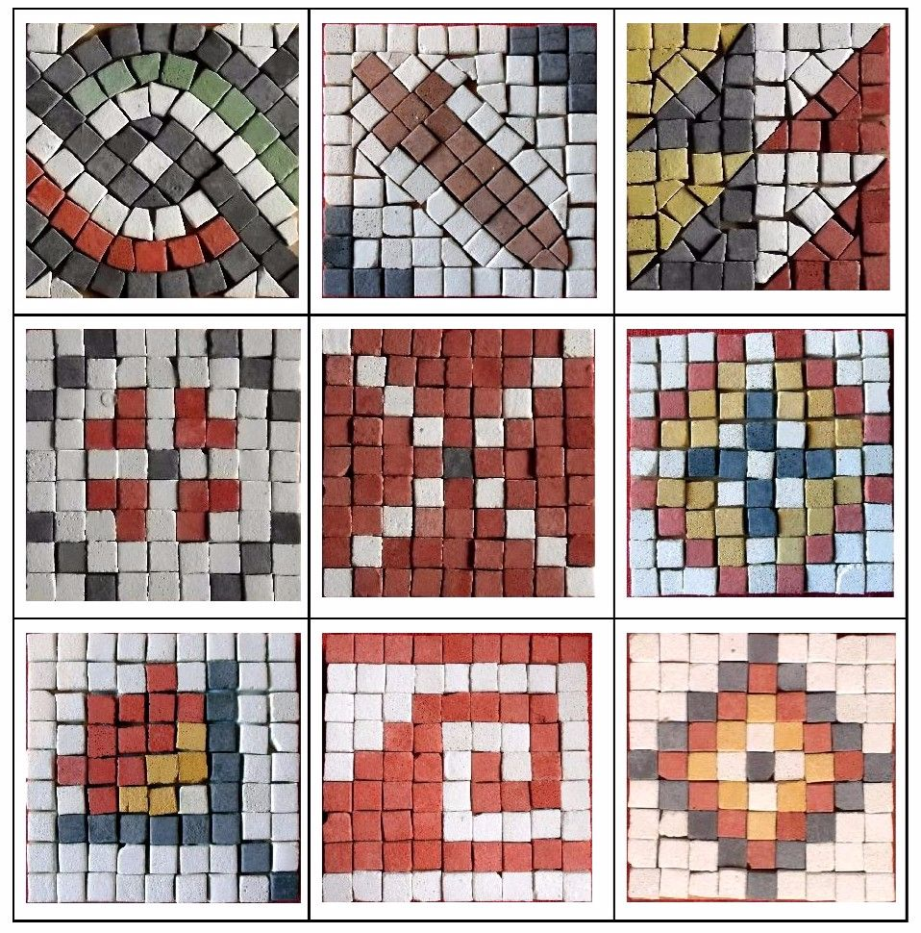I