|  |  |  |
| --- | --- | --- |
| **Bayeux Tapestry - Sewing** | **Year** | **2** |

Final piece

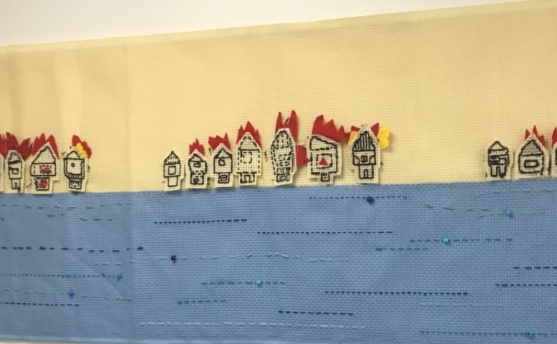

|  |  |
| --- | --- |
| **Vocabulary:** | |
| Thread | A long, thin strand of cotton used in sewing or weaving. |
| Linen cloth | A textile. It is very strong and therefore easily holds stitching in place. |
| Tapestry | A piece of thick textile fabric with pictures, formed by weaving threads. |
| Embroidery | The art of embroidering cloth. |
| Stitch | A loop or turn of thread or yarn in fabric. |
| Running stitch | A line of small even stitches which run back and forth through the cloth without overlapping.  C:\Users\c.lewis\AppData\Local\Microsoft\Windows\INetCache\Content.MSO\2E82F9A7.tmp |
| Backstitch | A method of sewing with overlapping stitches.  7 days of stitches: back stitch - Pumora - all about hand embroidery |
| Applique | Pieces of fabric are sewn or stuck on to a larger piece to form a picture or pattern. |

|  |  |
| --- | --- |
| **What will be taught through the unit:**   * **The history of the Bayeux Tapestry** * **How to sew and applique** * **How to join these parts together to tell a story** | |
| Art History | **Main inspiration: Norman conquest of England, by William Duke of Normandy.** Born in 1027. Battle of Hastings 1066 where he won. The coronation was on 25th December 1066, where he was crowned King of England. He became known as William the conqueror, because he won the battle. He died in 1087.  His brother Odo, Bishop of Bayeux commissioned the tapestry to be made in the 1070s, in England. It was rumoured that William’s wife sewed the tapestry, however due to it’s size it is believe that many different people worked on the tapestry. It was specifically designed to hand in Notre-Dame of Bayeux. It is a rare example of the Romanesque art style.  Despite the name, the Bayeux tapestry is actually an embroidery. IT has a combination of pictures and text. It is 70m long and is split into 9 panels. The design was sketched onto the tapestry before it was sewn. It is wool thread sewn onto linen cloth. The background of the tapestry is the natural cloth. The original tapestry was sewn using 7 different colours of thread, however the later repairs to the tapestry were done in an additional 3 colours. There are four different stitch types on the tapestry: stem stitch, chain stitch, split stitch and couching stitch (which is often referred to as the Bayeux stitch).  As well as depicting the Norman conquest of England, the Bayeux tapestry depicts everyday life the 11th century. |
| Art Appreciation-  Gallery Walk | C:\Users\c.lewis\AppData\Local\Microsoft\Windows\INetCache\Content.MSO\63D0394D.tmpC:\Users\c.lewis\AppData\Local\Microsoft\Windows\INetCache\Content.MSO\2CFEE5E3.tmp  Which people can you see? What part of the story do you think this part of the tapestry is? What can you see in the main section and in the border?  There are many military references, including armour, helmets, hauberk, oblong shields, castle mounds, seafaring and Viking ships. There are also real and imaginary animals, particularly across the top border. Many specific people are depicted throughout the tapestry. They are easily distinguishable due to each person’s facial hair and appearance being consistent throughout the tapestry. |
| Skills burst | Practice running stitch in a straight line on a piece of fabric  Sketch outline of a house and do running or back stitch (HA) to create house.  Applique felt/ material to the backing using running stitch. |
| Tools check | How to hold a needle.  Practice treading  How to use a running stitch.  HA- how to use a backstitch.  How to applique. |

**MANCHESTER ROAD PRIMARY ACADEMY - ART**