|  |  |  |
| --- | --- | --- |
| **Peter Thorpe-** | **Year 2** |  |

**MANCHESTER ROAD PRIMARY ACADEMY - ART**

Final piece

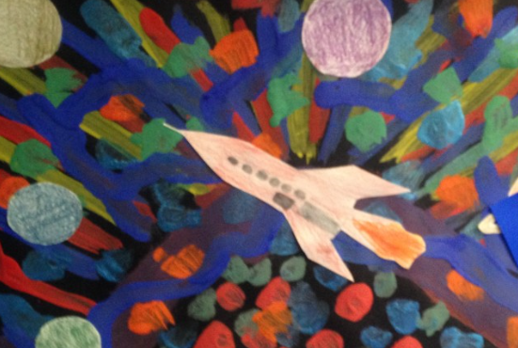

|  |  |
| --- | --- |
| **What will be taught through the unit:** | |
| Art History | **Peter Thorpe**  "I started the rocket paintings in the 1980s as a way to use paint that I would have otherwise thrown away. After each commercial job I did, there would be a pallet half full of paint left over and it pained me to toss it, but the next painting required a new pallet. It finally occurred to me that I could easily paint an abstract background on a blank board or canvas with the left over paint."  "But, what should I do with the abstracts?"  **Interest**: Space exploration and Science-fiction  **Style of paintings**: Abstract  **Techniques used**: contrasting colours  Shading on the planets and rockets to appear 3d |
| Art Appreciation-  Gallery Walk | [Image result for peter thorpe space paintings](https://www.bing.com/images/search?view=detailV2&ccid=Qs2/xiEd&id=22813FD2D0E80C1A21719E89A1E61B143933BC40&thid=OIP.Qs2_xiEdtszejYABrOx8BwHaJj&mediaurl=https://i.pinimg.com/originals/cf/31/2b/cf312b314233fb4560082b1239400f6e.jpg&exph=2581&expw=2000&q=peter+thorpe+space+paintings&simid=607986709006715593&selectedIndex=1&adlt=strict)[Image result for peter thorpe space paintings](https://www.bing.com/images/search?view=detailV2&ccid=Sy1ycBSk&id=44A60A43E7B5064B45F44D2D6E925677DED9C625&thid=OIP.Sy1ycBSkTdCPgQawWAsDEAHaKS&mediaurl=https://s-media-cache-ak0.pinimg.com/736x/4c/5a/18/4c5a180d9c63767aa05a8e620c634c01.jpg&exph=1023&expw=736&q=peter+thorpe+space+paintings&simid=607999898809011459&selectedIndex=0&adlt=strict)  What shapes/objects can you see?  How does the painting make you feel?  What can you see in the background/foreground? |
| Skills burst | Background- Discuss colour palette- which colours would stand out against black. How to make a darker colour brighter- by adding white.    Foreground- Rocket/planets- shading with paint – start with your darkest colour- adding white each time to develop lighter shades. Add a contrast colour to the edge of the rocket of planet to create the |
| Tools check | How to hold a paint brush.  How to take care of the bristles.  Brush stroke tutorial |

|  |  |
| --- | --- |
| **Vocabulary:** | |
| Abstract | A painting or sculpture that does not represent a person, place or thing in the natural world. |
| background | the part of a picture, scene, or design that forms a setting for the main figures or objects, or appears furthest from the viewer. |
| foreground | the part of a view that is nearest to the observer, especially in a picture or photograph.  "the intricate garden depicted in the foreground" |
| contrast | the state of being strikingly different from something else in close association. |
| line | Defines shape, the outer edges of something |
| form | Appearing 3-dimensional |
| texture | The feel or appearance of a surface, how rough or smooth it is |
| scale | The different sizes of shapes used |
| proportion | The size and shape of one object in comparison to another |
| Shade | How light or dark a colour is |