Art History | 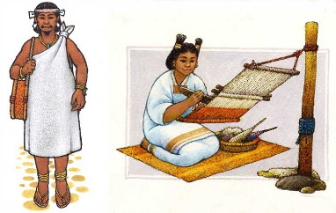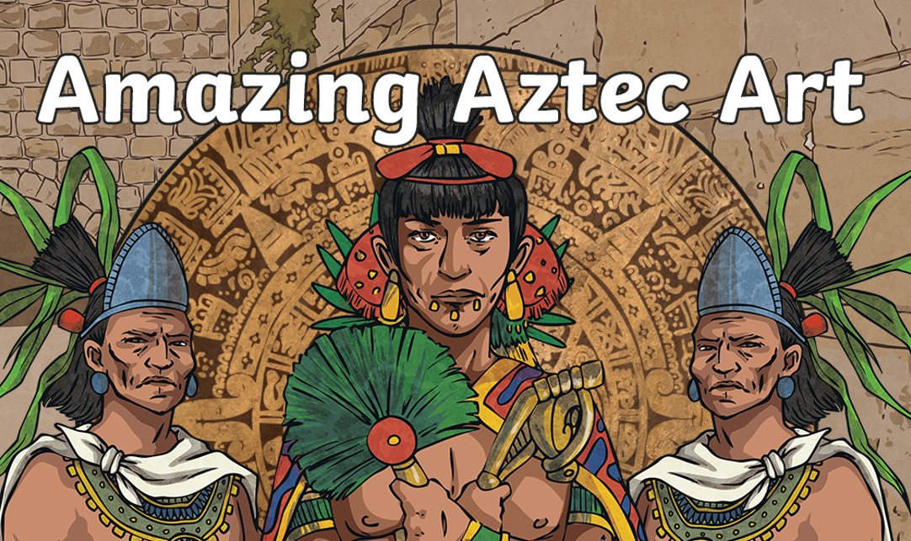  Nahua Textiles - Production and Use  For the Nahua peoples, textiles were an extremely important art form, but one that we actually know relatively little about. Why? Well, the hot and humid climate of Mexico isn't exactly conducive for the preservation of fabric, so much has been lost to history. Still, the Nahuas recorded much of their history, and Spanish priests recorded even more, so we have a good idea.  Traditional Nahua textiles were made with plant fibres from yucca, palm, maguey, or sometimes cotton. The fibres were spun into usable threads using a Mesoamerican style of spindle, the stone or clay components of which have survived and are found widely across Nahua archeological sites. After that, the threads were generally dyed and then woven using a distinct kind of loom called a backstrap loom. This was a wearable, portable loom that was strapped to the weaver around the waist and back, which allowed for a degree of mobility while weaving. Nahua textiles were very brightly coloured and utilized a diverse colour palette. Some textiles were woven with un-dyed materials, and later dyed in a technique similar to tye-dye. After being woven and dyed, many textiles were finely embroidered with various designs.  Textiles were a very important art form for Nahua peoples, and they were used widely. Rugs, blankets, and wall hangings decorated palaces and private homes alike. The common people wore woven tunics called huipils or poncho-like blankets called serapes, while the nobility enjoyed fine blankets worn over the shoulder to denote status and wealth. There were many, many kinds of these. For example, nacazminqui textiles were awarded by the emperor to warriors who had captured a number of enemies in battle. These blankets were defined by a two bold fields of colour, divided diagonally. The colours used could indicate just how valuable this nacazminqui was, and therefore how important the person was who wore it.  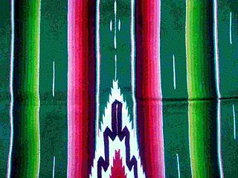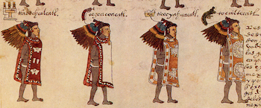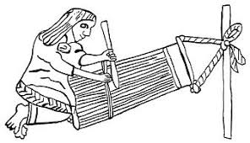  Aztec lords in this Nahua text are identifiable by their robes
Art Appreciation-  Gallery Walk | 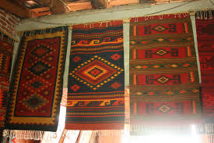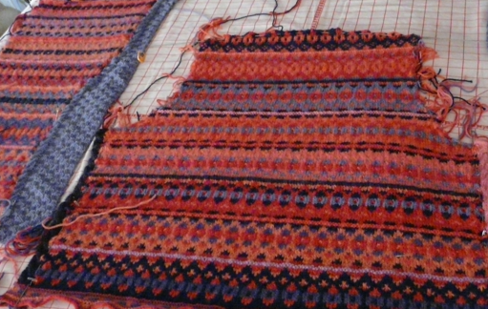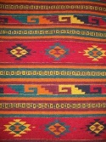  Look at the patterns and designs of Mayan fabric – is colourful, and would mainly have been used to cover walls and floors that were dull – also clothes and blankets.
Skills burst | Types of weaving-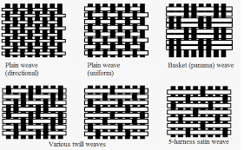  Skills burst- Investigate how different items of clothing are made- jumpers, jeans etc.  Children have a go of weaving different materials (paper, ribbon, wool, shredded denim etc) in art book. Weave in between card slats- concentrating on hand manipulation. Talk about torsion and what might happen to the finished article if the materials are pulled too tight.  - Colour Aztec patterns on the background of the paper plate.  - Weave wool / ribbon through slats in a paper plate creating patterns  - Thread beads and feathers and attach to the bottom of the plate
Evaluate | • Children evaluate their work and the result of the work once combined.  • Is it fit for purpose?  • Does it have the impact expected?
Vocabulary:
torsion | the action of twisting or the state of being twisted, especially of one end of an object relative to the other.
Weaving | Weaving is a method of textile production in which two distinct sets of yarns or threads are interlaced at right angles to form a fabric or cloth. Other methods are knitting, crocheting, felting, and braiding or plaiting.
textiles | A textile is a flexible material consisting of a network of natural or artificial fibres (yarn or thread). Yarn is produced by spinning raw fibres of wool, flax, cotton, hemp, or other materials to produce long strands. Textiles are formed by weaving, knitting, crocheting, knotting, tatting, felting, or braiding.
pattern | A repeated decretive designs.

Resources:
Paper plates
Wool
Ribbon
Beads
Feathers
Weaving board (EY)

Final Piece:
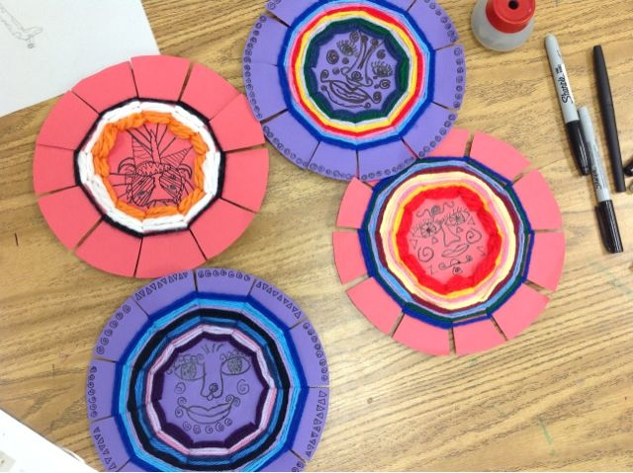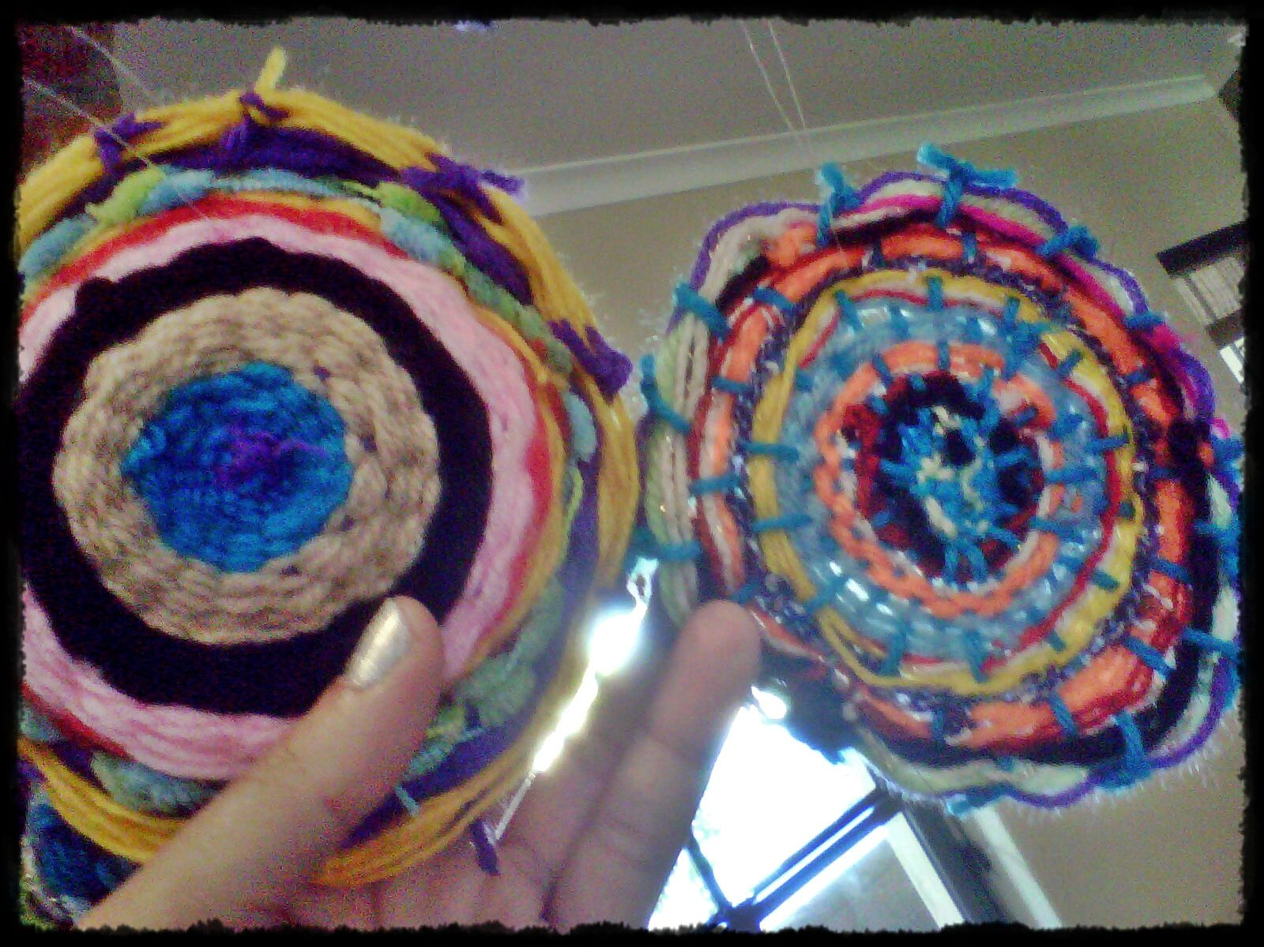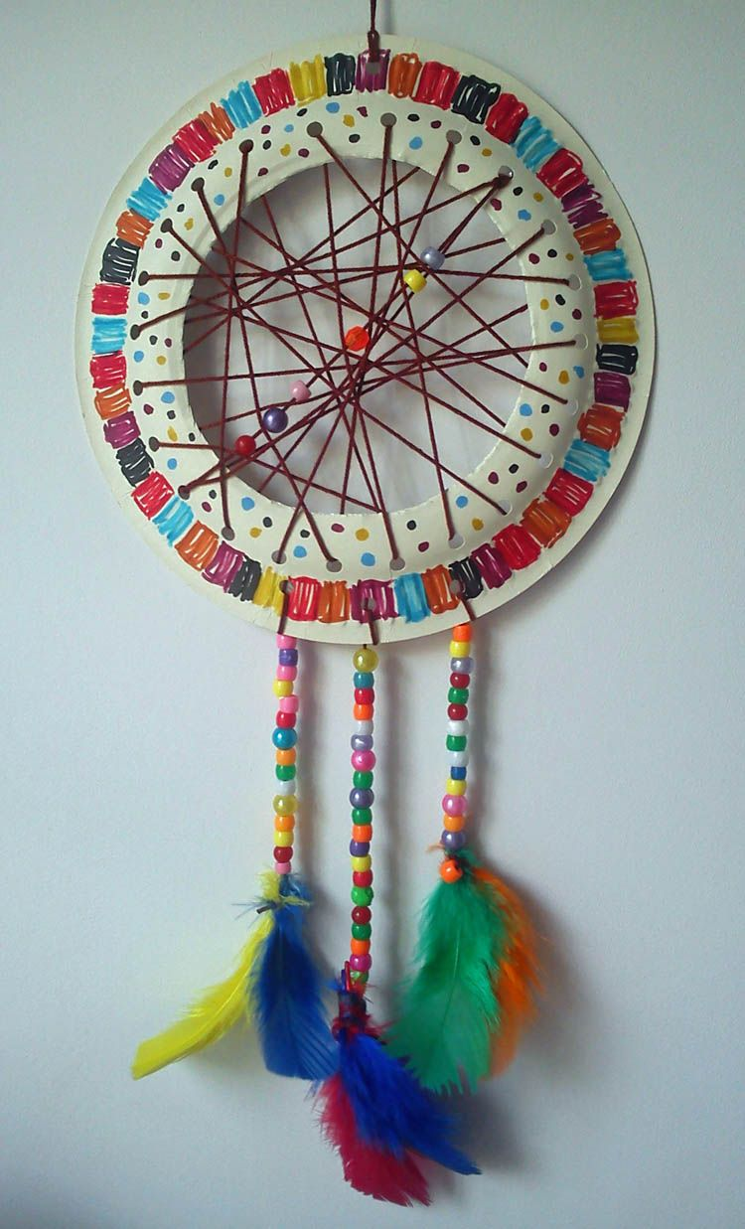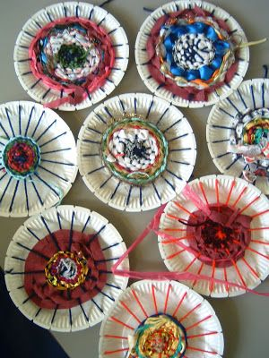
Hang the weave- you can add feathers and beads to create a dream catcher.

