Art History | Who is Claude Monet? Monet is a French painter born in 1840 and died in 1926  What is he famous for? Claude Monet is famous for impressionist landscape paintings.  Where did he get his inspiration? Monet’s inspiration came from nature and his environment.  Use a mind map to record findings.  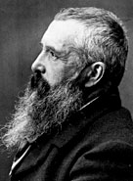
Art Appreciation-  Gallery Walk | 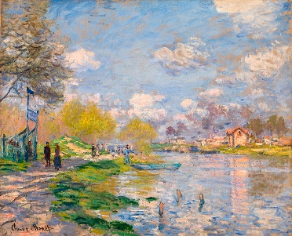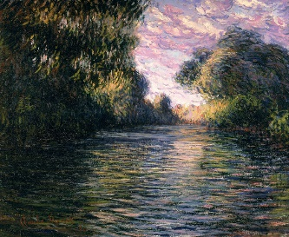  What can you see in the paintings?  How does this painting make you feel?  What materials are used in these paintings?  What part of the world do you think these paintings show?  What mood is Monet portraying in the paintings?
Skills burst | How can they use different shades and tones to create different moods for their river picture? – mixing colours, partly mixing to create water effects.  Tache technique – practicing the technique to create texture of water moving.  https://youtu.be/4vax9Xp8n-o  https://youtu.be/bMpEIrEEaHI
Evaluate | What do you like about your art work? What would you do differently next time? What did you enjoy about the process?  What do you like about your friends art work?
Vocabulary:
Impressionism | Originated in France in 1860’s. A style of painting that seeks to re-create the artist's or viewer's general impression of a scene
Landscape painting | A painting showing natural scenery. In this case a jungle.
Oil paint | Oil paint is a type of slow-drying paint that consists of particles of pigment suspended in a drying oil, commonly linseed oil.
Tache | A painting technique. Where you touch the canvas with your brush.
Flat end paintbrush | A paintbrush with flat bristles
Hue | pure spectrum colours commonly referred to by the colour names.
Tint | Mixing colours with white to make it lighter.
Tone | Refers to the lightness or darkness of a colour. The tone of a piece of art can have a variety of effects, from setting the mood to adding emphasis.
Shade | Mixing colours with black to make it darker.
Mood | The general atmosphere, or state of mind and feelings, that a work of art generates

Final Piece: Children to create a piece of river art using Tache technique. Children to create a piece that expresses their choice of atmosphere using different shades and tones.
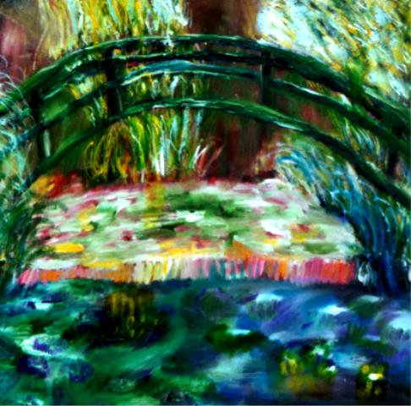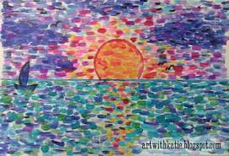

Resources:
Flat ended paint brushes
Acrylic paint – green, blue, yellow, white, brown
https://www.youtube.com/watch?v=-Ftb1mkN30g
Monet river painting examples

