Art History | Georges Seurat and Paul Signac developed the technique in 1886, branching from Impressionism. The term "Pointillism" was coined by art critics in the late 1880s to ridicule the works of these artists, but is now used without its earlier mocking connotation.^{[1]} The movement Seurat began with this technique is known as Neo-impressionism. The Divisionists used a similar technique of patterns to form images, though with larger cube-like brushstrokes.  In 1879 Georges Seurat enlisted as a soldier in the French army and was back home by 1880. Later, he ran a small painter's studio in Paris, and in 1883 showed his work publicly for the first time. The following year, Seurat began to work on La Grande Jatte and exhibited the painting in the spring of 1886 with the Impressionists. With La Grande Jatte, Seurat was immediately acknowledged as the leader of a new and rebellious form of Impressionism called Neo-Impressionism  Seurat painted A Sunday Afternoon between May 1884 and March 1885, and from October 1885 to May 1886,^{[4]} focusing meticulously on the landscape of the park. He reworked the original and completed numerous preliminary drawings and oil sketches. He sat in the park, creating numerous sketches of the various figures in order to perfect their form. He concentrated on issues of colour, light, and form. The painting is approximately 2 by 3 meters (7 by 10 feet) in size.  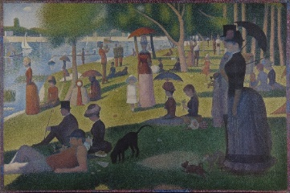
Art Appreciation-  Gallery Walk | 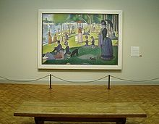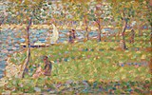  On display at the Art Institute of Chicago  What is happening in this painting?  What story does it tell?  What do you think the lady on the far right is thinking?  How does this painting make you feel?  What techniques does the artist use?  How does he create the feeling of bright sun compared with the splashing of shade?
Skills burst | Take a section of A Sunday Afternoon- the water- model using colour to create Start with your finest paint brush and make some dots around the highlight. Avoid putting any dots inside the highlight area, but make sure that the points gradually become more and farther apart closer to the highlight. You don’t want your marks to suddenly stop dead. As you move away from the highlight, place your dots closer together-Use lighter shades first.  Look at seascape after your visit to Llandudno- discuss how you would recreate the different tones/light/shade.
Evaluate | What do you like about your art work? What would you do differently next time? What did you enjoy about the process?  What do you like about your friends art work?
Vocabulary:
Pointillism | A technique of painting in which small, distinct dots of colour are applied in patterns to form an image. Georges Seurat and Paul Signac developed the technique in 1886, branching from Impressionism.
Landscape painting | A painting showing natural scenery. In this case a jungle.
Oil paint | Oil paint is a type of slow-drying paint that consists of particles of pigment suspended in a drying oil, commonly linseed oil.
Pointed end paintbrush | A paintbrush with pointed tip for fine pointillism technique
Tint | Mixing colours with white to make it lighter.
Tone | Refers to the lightness or darkness of a colour. The tone of a piece of art can have a variety of effects, from setting the mood to adding emphasis.
Shade | Mixing colours with black to make it darker.
Mood | The general atmosphere, or state of mind and feelings, that a work of art generates

Final piece
Using the skills practiced on A Sunday Afternoon. Sketch out the landscape of Llandudno. Use pointillism to
