Art History | Propaganda. Although propaganda is often used to manipulate human emotions by displaying facts selectively, it can also be very effective at conveying messages and hence can be used in web design, too.  War Propaganda Posters are well known. But at its core, it is a mode of communication aimed at influencing the attitude of a community toward some cause or position, and that doesn’t have to be a bad thing. Although propaganda is often used to manipulate human emotions by displaying facts selectively, it can also be very effective at conveying messages and hence can be used in web design, too.  PHILLIP ZEC: ENGLAND, 1930  Phillip Zec was probably best known for his depictions of Nazis as snakes and vultures. At the time, Nazis were usually drawn as bumbling clowns or buffoons. But Zec brought out the more sinister side of the German regime in his drawings. Hitler reportedly hated Zec so much that he added him to his black list and ordered his arrest following the invasion of Britain. He blamed Zec’s Jewish ancestry for his extreme ideas.  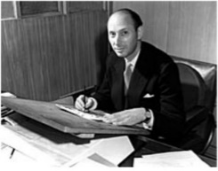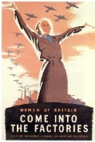  NORMAN ROCKWELL: US, 1939  Norman Rockwell is probably one of the best known of the propoganda movement. He admitted that he was just a propaganda stooge for the Saturday Evening Post. The newspaper paid many artists and illustrators to whitewash American news with patriotism and propaganda for around 50 years. 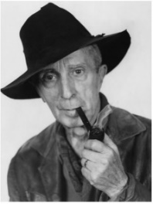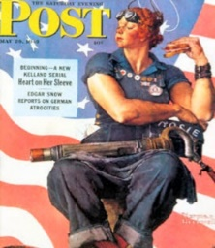
Art Appreciation-  Gallery Walk | Look at a range of Propaganda posters and investigate:  What is the message each poster is conveying?  Who are they aimed at?  What is the purpose?  What techniques has the artist employed to convey a message?  What colours are used and why?  What make the poster successful in conveying its message?
Skills burst | Experimenting- How can we print consistently and clearly? Try different ways of printing- with an object- leaves etc- why is this not the best way? Bleeds etc. Gradually move on to stencilling.  Stencilling- Draw design onto acetate-use craft knives to score out the design. Using acrylic paint and a cardboard squeegee to smooth the paint on to the material.  Main design- watch this video-https://www.youtube.com/watch?v=uIHOSzbNT8Q  - Children design their own propaganda poster on the computer in black and white- the black will be painted the white will not. This will be their stencil.  - Set up frames and printing material. Squeegee mixture of emulsion and sensitiser all across the screen. This needs to be done in the dark. Place the design on top of the screen- place in the sun (over 3 hours). Wash off excess emulsion.  - Attach screen to t-shirt- use clamps to hold them in place. Squeegee paint over the screen. Pull screen away, fill in any missing section with a paint brush. Add different colours to different sections. Once dry-Iron the T-shirt.
Evaluate | What do you like about your art work? What would you do differently next time? What did you enjoy about the process?  What do you like about your friends art work?
Vocabulary:
Propaganda | Propaganda is most well known in the form of war posters. But at its core, it is a mode of communication aimed at influencing the attitude of a community toward some cause or position, and that doesn’t have to be a bad thing.
Screen | Wooden frame
Emulsion | Screen printing emulsion is the light-sensitive liquid or capillary-direct films that you coat or adhere to the degreased screen fabric prior to taping your film positives in place.
Squeegee | A squeegee or squilgee is a tool with a flat, smooth rubber blade, used to remove or control the flow of liquid on a flat surface. It is used for cleaning and in printing.
stencil | Stencilling produces an image or pattern by applying pigment to a surface over an intermediate object with designed gaps in it which create the pattern or image by only allowing the pigment to reach some parts of the surface.
acetate | Acetate Paper is a transparent material that is made by reacting cellulose with acetic acid in the presence of sulfuric acid.

Resources:
https://www.youtube.com/watch?v=uIHOSzbNT8Q
Screen-wooden frames
Emulsion
Sensitiser
Acatates
Craft knives
Final Piece:
