Unit: Making an Egyptian Throne | Year 4 | Strand: KS2 Structures
Focussed Practical Tasks:
Making things stronger and stiffer
Pipe cleaners wrapped in newspaper.
Using card triangles to join card and wood

Vocabulary:
Frame  Structure  Stiffen  Strengthen  Reinforce  Stability  Shape  Design brief  Prototype  Annotated sketch  Purpose  Functional | a rigid structure that surrounds something such as a picture, door, or windowpane  a building or other object constructed from several parts.  support or strengthen (a garment or fabric), typically by adding tape or an adhesive layer  Make or become stronger  strengthen or support (an object or substance), especially with additional material  the state of being stable.  the external form, contours, or outline of someone or something.  a plan or drawing produced to show the look and function or workings of a building, garment, or other object before it is made.  a first or preliminary version of a device or vehicle from which other forms are developed.  A sketch with notes about different aspects of the design/product.  What something is for.  designed to be practical and useful, rather than attractive.

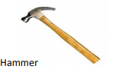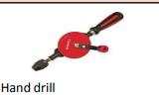
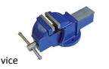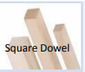
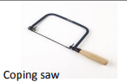

Types of wood join:
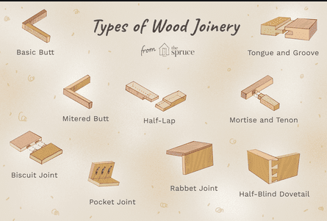
What will be taught through the unit:
Investigate: | - Why thrones were used in the past, and some of the most important thrones.  - How thrones are designed – both structurally and aesthetically – label different parts of thrones.  - Many royal thrones are ornate, and have many design features.
Design: | - What materials could a throne be built from?  - Wood is a good material, as it is strong and can be made into many different shapes and sizes using tools.  - Wood can also be treated with chemicals and wax so that it lasts for a long long time.  - How is wood joined?  - Wood can be joined in many ways using tools.  - A butt joint is a basic joint requiring glue or nails to join one piece of wood to another.  - What materials may children use to decorate, and how will these be added?  - Children need to think about comfort too – foam, fabric etc..  - Plan out a step by step method to making the product.
Make: | - The safe use of a saw, glue gun, hand drill.  - Measuring accurately is vital so that the chair doesn’t wobble. Children measure and mark out wood.  - A strong join will ensure the chair doesn’t collapse.  - How is the structure supporting the weight?
Evaluate: | - Discuss how the structure is supporting – is it stiff and strong enough?  - What improvements could be made?
Technological  Knowledge: | - Strengthen, stiffen and reinforcing the product.

Challenge: To make an Egyptian Throne
- To investigate thrones through the ages.
- To design and make a product using materials to make a throne fit for royalty.

MANCHESTER ROAD PRIMARY ACADEMY – Design Technology

