|  |  |  |
| --- | --- | --- |
| **Unit: Making a Fairground Ride** | **Year 3** | **Strand: KS2 - Structures** |

|  |  |
| --- | --- |
| **Vocabulary:** | |
| Pulley  Lever  Traction  Newton’s Law  Gravity | a wheel with a grooved rim around which a cord passes, which acts to change the direction of a force applied to the cord and is used to raise heavy weights  a rigid bar resting on a pivot, used to move a heavy or firmly fixed load with one end when pressure is applied to the other.  Pulling something across a surface  Every object in a state of uniform motion will remain in that state of motion unless an external [force](http://scienceworld.wolfram.com/physics/Force.html) acts on it.  the force that attracts a body towards the centre of the earth, or towards any other physical body having mass. |

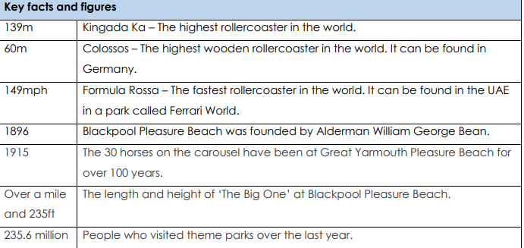

|  |  |
| --- | --- |
| **What will be taught through the unit:** | |
| Investigate: | * The history of fairground rides: * Roundabouts were first invented in early 19th century. * Rides developed quickly including the swinging yacht and the big wheel. * In 1910, as electricity became more widespread, the rides became powered by electricity. * Types of fairground ride: * Big wheel, roundabout, swinging roundabout. * All these work on a central mechanism which turns using a motor. The mechanism is either vertical or horizontal. |
| Design: | * Consider the design of the ride – children need to design seats as well as the actual mechanism so that a LEGO figure can be seated. * Design needs to include which ride they have chosen: ferris, roundabout or swing. * Use of electricity to either make the ride move. * Children draw a labelled diagram (see TTS kit) for their ride. * What design features are they going to use after construction? |
| Make: | * Children make the fairground ride (use TTS kits). * Children select materials and tools for the design. |
| Evaluate: | * Does the design fit the brief? * Does it move well? * What improvements could be made? |
| Technological  Knowledge: | * A motor is used to power fairground rides. * Levers and axles allow some rides to work. * There are safety factors associated with fairground rides. |

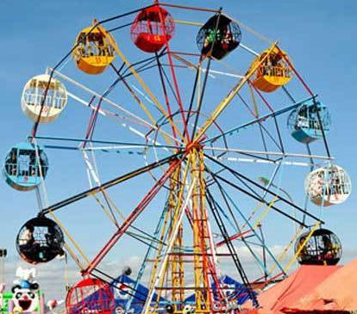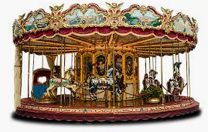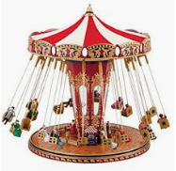

Ferris/ Big wheel carousel/roundabout Swing carousel

|  |
| --- |
| **Challenge: To make a moving fairground ride** |
| * To know about the history of fairground rides. * To understand the structures used in different fairground rides. * To know about the electrical circuits in a product. |

**MANCHESTER ROAD PRIMARY ACADEMY – Design Technology**