Unit: Making a Tasty Bread | Year 5 | Strand: KS2 - Food
Vocabulary:
Yeast  Rise  Proofing  Dough  Crust  Knead | A fungus which causes bread to rise  To increase in size  When yeast is activated do to adding water and dough rises.  A mixture of flour and liquid to make bread and pastry.  Part of the bread on the outside which is darker and harder.  Preparing the dough by pressing hard and continuously.

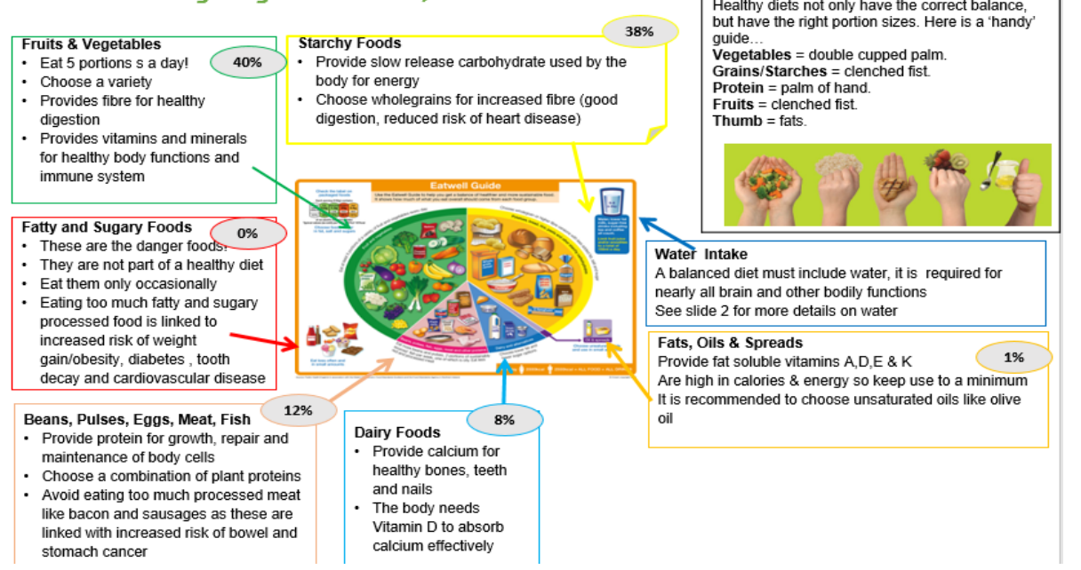
What will be taught through the unit:
Investigate: | - The history of bread through the ages and in different countries.  - How different breads are made – what ingredients they use. Include breads from different countries: baguette, soda, rye, pitta, naan.  - Where ingredients come from: flour, oil, salt, water, yeast.  - Investigate main ingredients of bread and how it is made.  - Yeast plays an important part in the making of lots of bread products. (see chart below for other ingredients)  - https://www.youtube.com/watch?v=w3O8lKnBhu8 (how bread is made).  - In order to rise and be soft, yeast is used to help bread rise.  - Temperature is important in the making of bread. It has to be warm.  - Children taste several different bread types – comment on packaging, how it looks and how it tastes.  - How bread contributes to part of a healthy diet.
Design: | - Children design a loaf based on a particular consumer: spicy, herby, fruity etc…  - Children investigate what ingredients and tools they will need to use.  - Children write the recipes for their bread.  - Children design a packaging that they feel will sell the bread.
Make: | - Children make the bread they have designed.  - Select tools and ingredients from the design.
Evaluate: | - Children taste the bread and get other children in school to taste and score based on label design, how appealing the product is, and the taste of the product.
Technological  Knowledge: | (see chart above)

Challenge: To make a balanced soup
- To revise the need for a healthy diet, and what this is.
- To identify groups of foods and why we need them to thrive.
- To know the origins of different types of food and how they are grown/ reared/ processed.
- To prepare and bake a loaf of bread using correct tools and ingredients.

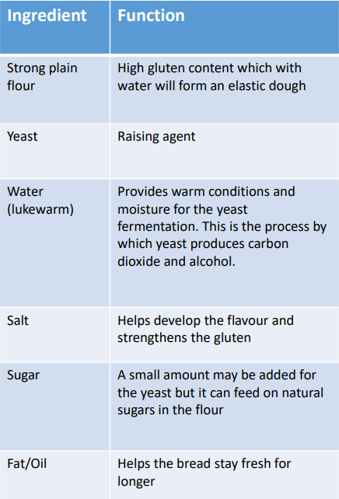

MANCHESTER ROAD PRIMARY ACADEMY – Design Technology

