|  |  |  |
| --- | --- | --- |
| **Unit: Making a Healthy Soup** | **Year 3** | **Strand: KS2 - Food** |

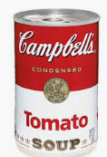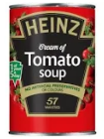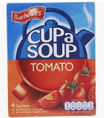

|  |  |
| --- | --- |
| **Vocabulary:** | |
| Brand  Ingredients  Consumer  Diet  Hazard  Logo  Portion  Recipe | A product manufactured under a particular name.  Foods and substances combined to make a dish.  The person buying and eating the food.  What we eat and drink.  Any dangers  A symbol adapted by a company to recognise a product  An amount suitable for one person  a set of instructions for preparing a particular dish, including a list of the ingredients required |

|  |
| --- |
| **Challenge: To make a balanced soup** |
| * To revise the need for a healthy diet, and what this is. * To identify groups of foods and why we need them to thrive. * To know the origins of different types of food and how they are grown/ reared/ processed. * To prepare and cook a soup with balanced ingredients. |

|  |  |
| --- | --- |
| **What will be taught through the unit:** | |
| Investigate: | * The history of soup: -AUTUMN 1 * Soup is believed to have been around from as far back as 20,000BC. * The word soup comes from the French word soupe which means both. * Canned and condensed soup was invented by Campbells in 1897. * You can now buy canned, condensed, dried and fresh soups widely in lots of different flavours. * What are the key ingredients in 2 types of soup? The history of soup: -AUTUMN 1 * Ensure there is a meat option to investigate. * The ingredients come from different places – which are grown, processed, reared? Investigate this so children have an awareness of food origins. * How is soup made? Chopped ingredients which are boiled in water. <https://www.youtube.com/watch?v=kXghgXg4Wss> * What is the nutritional value of soups? Would the soups chosen be considered balanced? * Nutrients include fibre, protein, carbohydrate, vitamins etc… * How are soups labels designed? * Children taste and evaluate different types of soup, including fresh, canned and dried – how do they taste? What nutrition do they hold?? What ingredients are in them? |
| Design: | * Children design a soup which is balanced. * Ensure they have fibre, protein and carbohydrates (pulses are a non – meat protein) * What ingredients and tools will they need to make the soup? * How much will the soup cost? * Who is the soup for? Why will they like it? * What will the label look like so it is appealing? |
| Make: | * Children make a soup using ingredients and selected tools from their design. * Consider the safety aspects of food preparation – using tools safely and food hygiene. * Design and make the label for the soup. |
| Evaluate: | * Children taste the soups and score against the label, the look/ presentation, the nutritional value and the taste. |
| Technological  Knowledge: | * How to chop ingredients in different ways – knife, chopper, grating. * Making judgements about timing dependent on ingredients. * Boiling temperatures, simmering. |

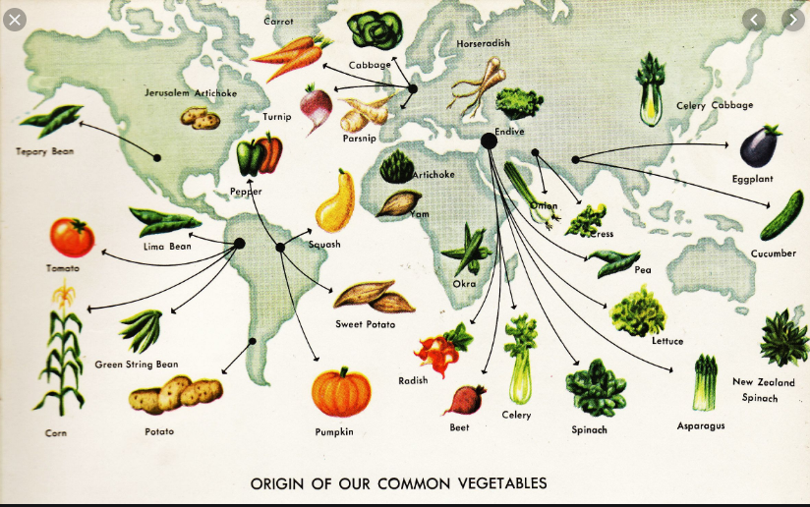

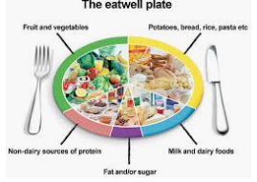

**MANCHESTER ROAD PRIMARY ACADEMY – Design Technology**