|  |  |  |
| --- | --- | --- |
| **Unit: Building a Moving Vehicle** | **Year 2** | **Strand: KS1 - Mechanisms** |

|  |  |
| --- | --- |
| **Vocabulary:** | |
| Axle  Axle Holder  Chassis  Friction  Dowel | A rod that enables a wheel to rotate. The wheels can rotate freely or be fixed to the rod so the axle moves too.  The component through which an axle fits and rotates.  The base on which a vehicle is built.  Resistance encountered when two things rub together.  Wooden rods used for making axles to hold wheels. |

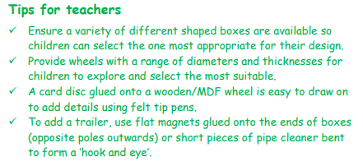

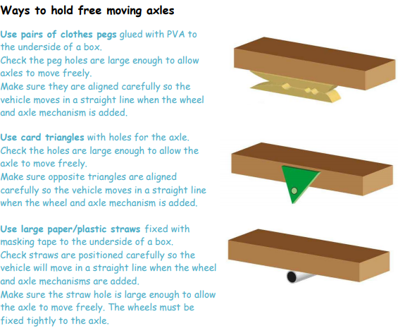

|  |  |
| --- | --- |
| **What will be taught through the unit:** | |
| Investigate: | * Children investigate what a moving vehicle is – what different types of vehicle are there: Bikes, cars, ambulance, lorry, train, aeroplane, fire engine, motorbike etc… * What the purpose of vehicles is: to make life easier, to enjoy playing. * Children look at the moving parts of vehicles and identify wheels, chains, axles, steering mechanisms. * Children disassemble a LEGO vehicle to look at the axles. * Children are given materials to experiment with making an axle. |
| Design: | * What vehicle are you going to make? What is it going to need to work well? Children can make a 2/3/4 wheeled vehicle, a vehicle with a different purpose etc… * What key features will be needed to build their vehicle? Axle, wheels, ladder, chassis, lights etc… * Children design a vehicle using key vocabulary and technical drawings. * Design features * Technical components * Finishing design |
| Make: | * Children experiment with axles and wheels, attaching a chassis – and discuss the amount of friction needed for the wheels to turn well Use construction kits and other materials to experiment.. * Children construct a vehicle using their design brief. * Children select tools and materials to construct their design. |
| Evaluate: | * Children evaluate the vehicles using correct vocabulary. * Evaluate for its design and it’s functionality. |
| Technological  Knowledge: | * Chassis - * Axles - |

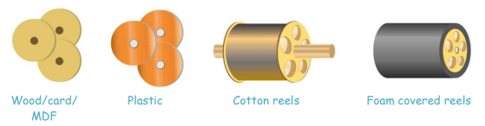

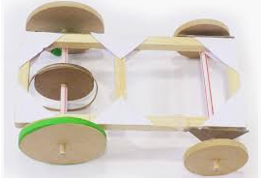

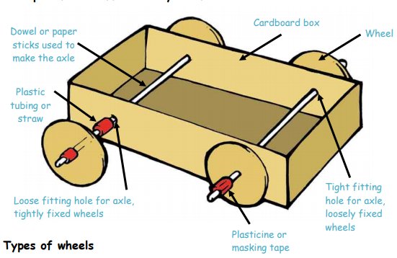

|  |
| --- |
| **Challenge: To make a structure - homes** |
| * To build a vehicle using different materials. * To know the component parts of a vehicle * To understand how an axel works in a vehicle |

**MANCHESTER ROAD PRIMARY ACADEMY – Design Technology**