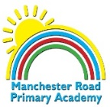
National Curriculum PoS – Geography
Locational knowledge
- name and locate the world’s 7 continents and 5 oceans
- name, locate and identify characteristics of the 4 countries and capital cities of the United Kingdom and its surrounding seas
Place knowledge
- understand geographical similarities and differences through studying the human and physical geography of a small area of the United Kingdom, and of a small area in a contrasting non-European country
Human and physical geography
- identify seasonal and daily weather patterns in the United Kingdom and the location of hot and cold areas of the world in relation to the Equator and the North and South Poles
- use basic geographical vocabulary to refer to:
  - key physical features, including: beach, cliff, coast, forest, hill, mountain, sea, ocean, river, soil, valley, vegetation, season and weather
  - key human features, including: city, town, village, factory, farm, house, office, port, harbour and shop
Geographical skills and fieldwork
- use world maps, atlases and globes to identify the United Kingdom and its countries, as well as the countries, continents and oceans studied at this key stage
- use simple compass directions (north, south, east and west) and locational and directional language [for example, near and far, left and right], to describe the location of features and routes on a map
- use aerial photographs and plan perspectives to recognise landmarks and basic human and physical features; devise a simple map; and use and construct basic symbols in a key
- use simple fieldwork and observational skills to study the geography of their school and its grounds and the key human and physical features of its surrounding environment

Y1 – Locational Knowledge -Flight
Locational Knowledge:
Vocabulary
Map | A diagram that shows images of land and sea showing physical and human features.
Continent | The main land masses on Earth. Currently there are seven
Poles | Areas of land at the top and bottom of the Earth.
Country | A state or nation. (July 2020 there are 195 countries in the world)
Sea | Salt waters that cover the Earth’s surface
Ocean | Salt waters that cover the Earth’s surface (July 2020 there are 5 oceans in the world)
globe | A sphere with an image of the world drawn/ printed on
atlas | A collection of maps

The Earth has 7 continents and 5 oceans:

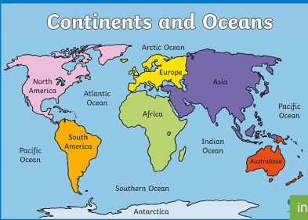

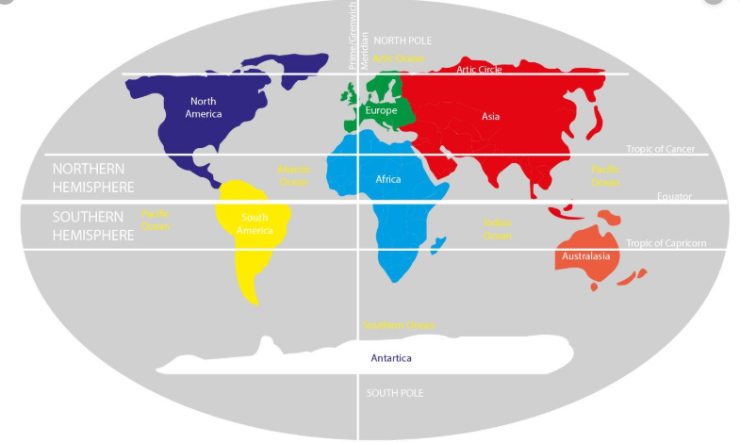

Map Skills:
Plotting a trip from England to Australia – what continents do you cross?

