National Curriculum PoS – Geography
Locational knowledge
- name and locate the world’s 7 continents and 5 oceans
- name, locate and identify characteristics of the 4 countries and capital cities of the United Kingdom and its surrounding seas
Place knowledge
- understand geographical similarities and differences through studying the human and physical geography of a small area of the United Kingdom, and of a small area in a contrasting non-European country
Human and physical geography
- identify seasonal and daily weather patterns in the United Kingdom and the location of hot and cold areas of the world in relation to the Equator and the North and South Poles
- use basic geographical vocabulary to refer to:
  - key physical features, including: beach, cliff, coast, forest, hill, mountain, sea, ocean, river, soil, valley, vegetation, season and weather
  - key human features, including: city, town, village, factory, farm, house, office, port, harbour and shop
Geographical skills and fieldwork
- use world maps, atlases and globes to identify the United Kingdom and its countries, as well as the countries, continents and oceans studied at this key stage
- use simple compass directions (north, south, east and west) and locational and directional language [for example, near and far, left and right], to describe the location of features and routes on a map
- use aerial photographs and plan perspectives to recognise landmarks and basic human and physical features; devise a simple map; and use and construct basic symbols in a key
- use simple fieldwork and observational skills to study the geography of their school and its grounds and the key human and physical features of its surrounding environment

Y2 Comparing a contrasting non – European Locality - Mombasa
Locational Knowledge:
- Kenya is located in East Africa on the Equator.
- Nairobi is the largest city in Kenya. Mombasa is the second. It is a coastal seaport city:
- The Indian Ocean is the coast on which it lies
- It has a port and an airport
- It is a major tourist destination in Kenya
- There are many family entertainment venues – waterparks, cinema, bowling, go – karts etc…
- Kenya shares Lake Victoria – the worlds second largest fresh water lake with 2 other African countries: Uganda and Tanzania.
- Kenya features many national parks and wildlife reserves and safaris are a popular activity for visitors.
- Agriculture is important in Kenya for the economy. Especially tea, coffee and flowers.
- Mombasa has a flat topography.

See Chart below for direct comparisons.

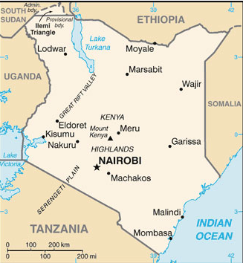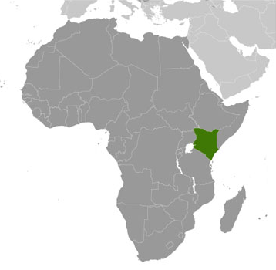
Useful Websites:  https://www.bbc.co.uk/programmes/p0114ch0  https://kids.kiddle.co/Mombasa | Map Skills:  Use of simple maps to describe position: N,S,E,W, and to identify features using OS symbols.  Use aerial photographs and maps to identify features and landmarks.  Plot a route from London to Mombasa
London:  Physical Geography:  - Inland city  - On the side of the River Thames  - flat  Main types of building:  - apartments, high rise flats, offices, shops, hospitals, public buildings, museums, airport, railways, tube, university, churches and places of worship, hotels  Climate:  - Tropical wet and dry. | Mombasa:  - Coastal city with a port  - Flat  - Lower rise apartments, houses, hospital, museum, port, harbour, shops, offices, old town and new town, churches and temples, hotels  Climate:  - Oceanic climate

Mombasa Climate:
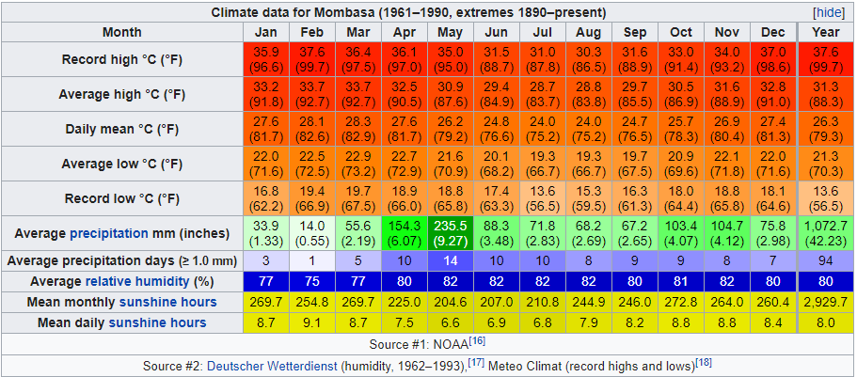

London Climate:
