**MANCHESTER ROAD PRIMARY ACADEMY - GEOGRAPHY**

|  |  |  |
| --- | --- | --- |
| **Unit: Rainforest Climates** | **Year 3** | **Strand: Human and Physical Geography** |

|  |  |
| --- | --- |
| **What will be taught through the unit:**   * **To use the correct geographical words to describe a place** * **To understand the characteristics of a tropical rainforest** * **To learn about the interdependence of climate, water, soils, plants, animals and people.** * **How animals and plants adapt to the rainforest - biomes** | |
| Where are the rainforests of the world and why are they important? | * Most of the world’s rainforests lie between the Tropic of Cancer and the Tropic of Capricorn. * These imaginary lines are around 22 degrees north and south of the Equator. * The worlds largest rainforest if the Amazon in South America.   Rainforests are important because:   * they cover only 2% of the surface of the Earth, but account for around 50% of all life on Earth’s land masses. * The life in the rainforest is very interdependent – if one thing changes in that place, a whole species can become extinct. * The vegetation in the rainforest absorbs carbon dioxide from the air and releases oxygen. * There are many ingredients that we use in medicines grown there. |
| What is the climate like in South America? | Compared with Britain, the climate in the rainforest is very warm and very wet:  See charts. |
| What is a biome? | A biome is a place where the animals and plants that grow there are dependent on the climatic conditions.  Biomes include:  Deserts, rainforests, savannah, woodlands, grasslands and tundra. |
| Impact of deforestation. | Deforestation occurs due to:  Logging, farming, mining, road building, settlements, dam building.  The impact of deforestations is wide – spread and critical:  Less plants and animals, loss of habitats, soil erosion, silting up of rivers, flooding, global warming. |

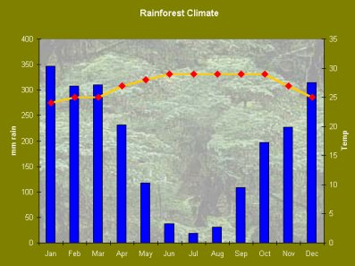

**Rainfall and Temperature in the Amazon**

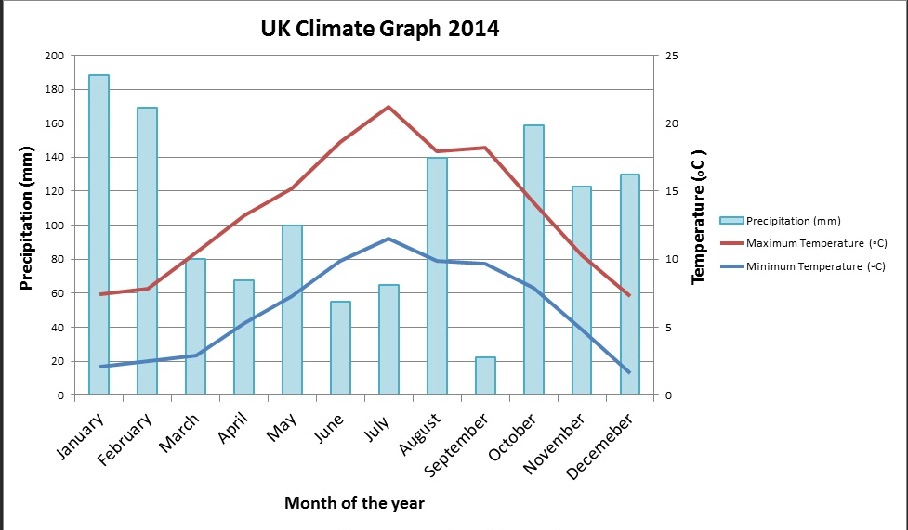

**GLOBAL WARMING:**

The destruction of trees causes more carbon dioxide to be in the air which is increasing the Earth’s temperature. The increase in temperature causes climates to change and the melting of the polar ice caps. This is having devastating effects all over he world.

## **What can be done to protect tropical forests?**

* Selective logging - only some trees cut down.
* Using elephants, horses or helicopters to drag or fly selected logs out.
* Replanting trees.
* Environmental laws which make logging illegal, though this is hard to police.
* Setting up national parks and nature reserves.
* Encouraging ecotourism.
* Encourage people to stop buying tropical hardwood.
* Helping poorer countries develop - so they don't have to use rainforest resources unsustainably.

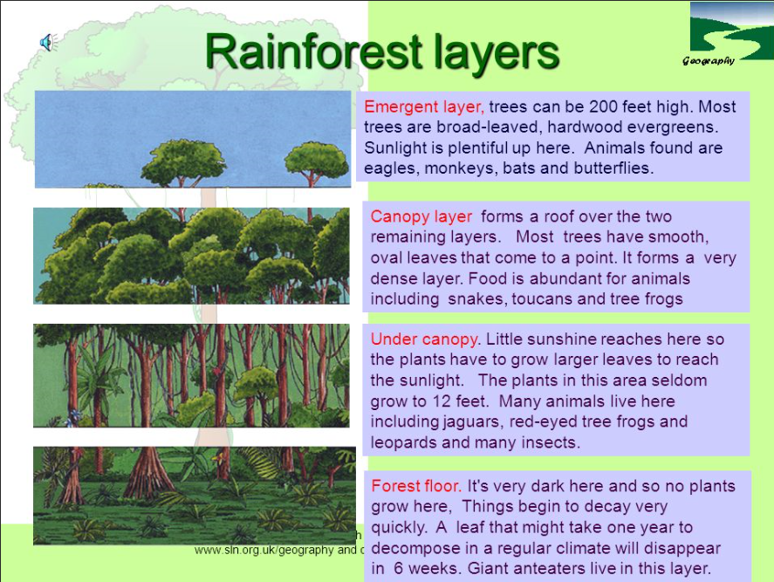

**The emergent layer**

* The tallest layer - over 40 metres.
* Contains only a few tall trees which grow taller than the trees of the canopy.
* The plants are made for living in dry conditions because it’s very sunny.
* They have small, waxy leaves to prevent them drying out.

Eagles, butterflies, small monkeys and bats all live here.

**The Canopy**

* The second highest layer - 30-45 metres.
* The crowns of the trees knit together to form a dense canopy.
* The canopy blocks out the sun from lower layers and intercepts (catches) rainfall.
* It contains the most plant species.

Birds, monkeys, frogs, sloths, lizards, snakes and many insects live here. This layer contains the most animal species. Some creatures never go to the forest floor.

Video on climate zones: <https://www.bbc.co.uk/bitesize/clips/zr7hyrd>

<https://www.bbc.co.uk/bitesize/topics/zvsfr82/articles/zd4rmfr>

https://www.theschoolrun.com/homework-help/rainforest-habitats

**Understory**

* Low light conditions (2-15%).
* Quite open - there is only dense vegetation along rivers and in openings where light gets in.
* Plants adapted to low light grow here.

Birds, butterflies, frogs, snakes and lots of insects live here

**Forest floor**

* Very little light reaches the forest floor (2%) - so plants grow slowly.
* The ground is covered in fallen leaves, rotting branches and twigs and a network of shallow roots.
* When a tree falls, light is able to get in. This encourages young plants to grow fast. They compete for the extra light and soon fill the gap.

Jaguars, leopards, tigers, elephants and gorillas are found in different rainforests around the world. Lots of insects live here

|  |  |
| --- | --- |
| **Vocabulary:** |  |
|  |  |
|  |  |
|  |  |
|  |  |
|  |  |
|  |  |
|  |  |
|  |  |
|  |  |
|  |  |
|  |  |
|  |  |
|  |  |
|  |  |
|  |  |
|  |  |
|  |  |
|  |  |
|  |  |
|  |  |