**MANCHESTER ROAD PRIMARY ACADEMY - GEOGRAPHY**

|  |  |  |
| --- | --- | --- |
| **Unit: Rivers** | **Year 5** | **Strand: Human and Physical Geography** |

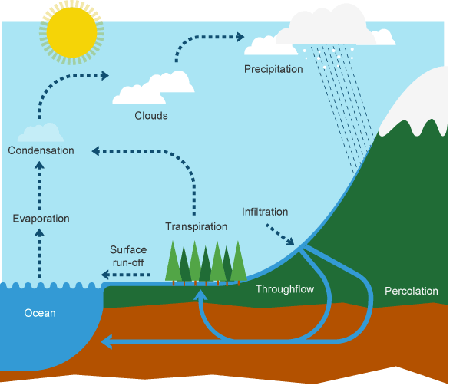

|  |  |
| --- | --- |
| **What will be taught through the unit:**   * **The importance of rivers and the water cycle.** * **To describe the life of a river using the correct terminology** * **Why rivers are importance and their role in settlement formation** | |
| The difference between bodies of water. | * An ocean is a very large body of salt water that separates land, * Seas are smaller areas of water which separate oceans and land. * Rivers are natural streams of fresh water that flow into seas, oceans and lakes. |
| Key rivers around the world: | Children will have already studies the Nile and the Amazon.   * The Ganges – India & Bangladesh * The Yangtze – China * The Mississipi – Missouri (USA) * The Yenisei – (Russia) |
| The water cycle | Rivers are an important part of the water cycle:   * Energy from the sun heats the surface of the land. * Water is evaporated from the oceans, rivers and lakes. * Warm air rises because it is less dense (particles are not as close together) * Condensation occurs when the vapour cools – clouds are then formed. * Precipitation (rain) happens as the droplets get bigger and heavier. They may fall as rain, sleet, snow. * The precipitation is carried across the land. Some of it will run into rivers. |
| How rivers are formed | Rivers are formed through the processes of erosion and deposition. (See table and diagrams)   * Most rivers begin in hills and mountains where the land is high. * They are fed by melting snow and rain. * Small streams in the mountains join together to make rivers. The water follows cracks in the land.   Erosion:   * Land is worn away and stones carried in the river. * Erosion can happen through corrosion (the water hitting against the river bed), attrition (rocks and pebbles wearing away the river bed), chemical action (water breaking down minerals in the rocks and washing them away). |

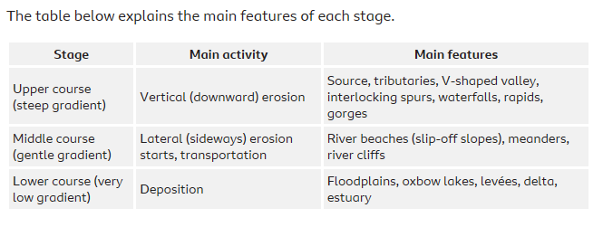

**In the upper course the water flows fast, in the middle course it slows and may meander, in the lower course, rivers flow slower across flat land.**

|  |  |
| --- | --- |
|  | Transportation:   * Traction (Large stones are rolled or dragged along by the force of the water) * Saltation (small stones bounce off each other and travel short distances) * Suspension (smaller stones which can be carried long distances by the water)   Deposition   * When a river loses speed, meets with deeper water or hits a meander, it loses energy and the materials it is carrying are dropped. |
| Rivers on maps | Children must learn to follow the route of a river on a map – describing features as they go.  <https://www.bbc.co.uk/bitesize/guides/zyt9q6f/revision/6> |
| Causes of flooding | Floods can occur through natural or human causes:  Natural causes can be after prolonged rainfall, geology, relief.  Human causes include urbanisation, deforestation, agriculture  How we can manage flooding:  Soft engineering – working with the rivers natural processes to protect communities and habitats. It does not involve man – made structures: planting trees, floodpains, flood warnings.  Hard engineering – using artificial structures to slow down the flow of rivers: dams and reservoirs, embankments, channel straightening. |

|  |  |
| --- | --- |
| **Vocabulary:** |  |
| biome | A natural source of vegetation and animals |
| climate | The general weather conditions typical of a place |
| confluence | When two river join and become a larger river |
| course | The pathway along which a river flows |
| current | A continuous flowing movement of some of the water in a river. Lake or sea. |
| delta | An area of land where a river splits into several channels before entering the sea. |
| deposition | When a substance has been left somewhere as a result of a process. |
| erosion | The gradual destruction and removalof rock and soil in a particular areas by the river or sea. |
| estuary | Wide part of the river where it joins the sea |
| lake | An area of fresh water surrounded by land |
| meander | A large bend in the river |
| mouth | Where a large river flows into the sea |
| ocean | One of the 5 large bodies of salt water on the Earth’s surface |
| pollution | The process of polluting air and water with poisonous chemicals |
| sedimentary | Solid material that settles at the bottom of a liquid, especially earth and pieces of rock that have been carried along and then left somewhere by water, ice or wind |
| source | Where something comes from |
| stream | A small, narrow river |
| tributary | A stream or river that flows into a larger one |
| Water cycle | The circulation of the Earth’s water |
| waterfall | A place where water flows over the edge of a steep, high cliff in hills or mountains and into a basin. |

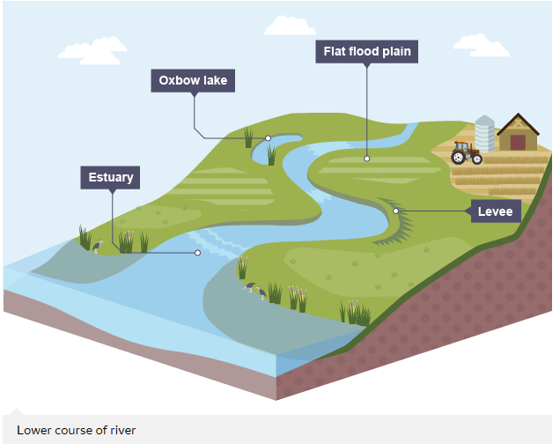

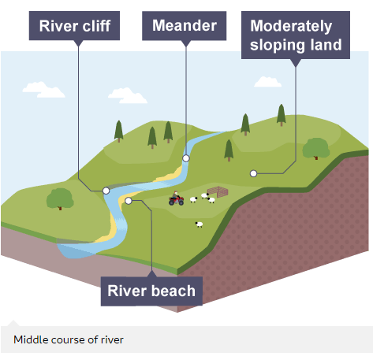

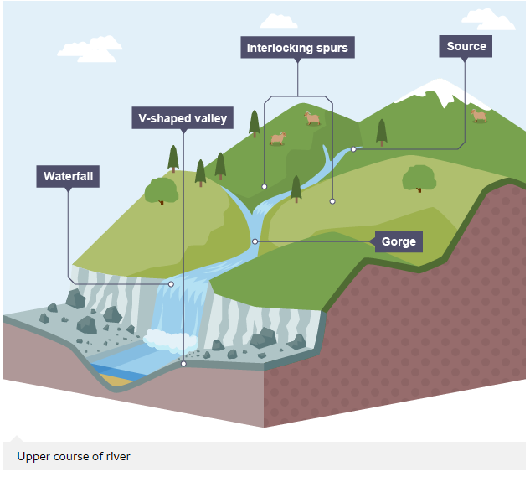

THE BBC BITESIZE VIDEOES, VOCABULARY AND EXPLANATIONS ARE VITAL TO THIS TEACHING – PLEASE USE THEM THROUGHOUT LESSONS AND PLANNING.

https://www.bbc.co.uk/bitesize/guides/zyt9q6f/revision/4