**MANCHESTER ROAD PRIMARY ACADEMY - HISTORY**

|  |  |  |
| --- | --- | --- |
| **Unit: The Ancient Greeks** | **Year 5** | **Strand: Ancient Greece and their Impact on the Western World** |

|  |  |
| --- | --- |
| **What will be taught through the unit:**   * **When the Ancient Greek civilisation was developed.** * **That there are a lot of archaeological finds which tell us about life in Ancient Greece.** * **About how life in Ancient Greece had an impact on the western world, and Britain.** | |
| Location of Ancient Greece: | **(See map)** |
| The significant events in the timeline: | (See timeline p2) |
| The landscape | * The Greek landscape contributed a lot to the civilisations that developed. * It has many uneven coastlines, mountains and dry areas of land, which meant that people living in different areas of Greece became very proud and protective about their particular area. * As the landscape was so difficult to navigate, the Greeks developed their seafaring skills, building boats and ships to travel around. |
| How do we know about life in Ancient Greece? : | * There are many archaeological finds both on the land and in the sea. * The Greeks developed art and writing/language, and lots of what we know is due to the stories and records that were made on pots and in buildings. * There are many buildings and ruins left from Ancient Greece today – they tell us about the tools and materials the civilisations must have had. |
| Facts about Ancient Greece: | * The Greeks called themselves **Hellenes** and their land was **Hellas** * The **Minoans** were the first great Greek civilisation. They didn't live on mainland Greece but on the nearby **island of Crete**, between 2200BC and 1450BC. * After the Minoans came the **Mycenaean civilisation**, from mainland Greece. They were fine builders and traders, but they were also great soldiers. (Investigate battle of Troy). * After the Mycenaean age ended in about 1100BC, Greece entered a **Dark Age**. It is known as a dark age because nobody knows much about what happened - all written language and art disappeared. (Why do children think this could happen? Famine? Drought? People moved away because of hardship?) * Around 480BC Greece entered a golden age which lasted for 200 years. The people built fantastic temples, made scientific discoveries, wrote plays and founded the first proper democracy. Historians call this **Classical Greece**. * The final period of Greek history is known as the **Hellenistic** period. This lasted from 323BC to 30BC, when the Romans took control of Greece. The Romans didn't destroy Greek life, though. They respected the Greeks and copied many things about their culture, including their buildings, beliefs and clothes – They then took these ideas around the world. * Only a very powerful ruler could control all Greece. One man did in the 300s BC. He was **Alexander the Great**, from Macedonia. Alexander led his army to conquer an empire that stretched as far as Afghanistan and India. (Find out about his conquests and the Greek Army – he invaded Ancient Egypt…recall) |
| How have the Ancient Greeks influenced life in Britain today? | * Democracy was invented in Ancient Greece – It was different to modern day democracy, but still allowed people to have the power in making decisions. This contributed even more to the success of Ancient Greece, as the people wanted to work harder to make their decisions work. * Sports events and the Olympics were started in Ancient Greece – It was a very popular event. * Language around the world has many Greek origins. |

A map of Ancient Egypt:

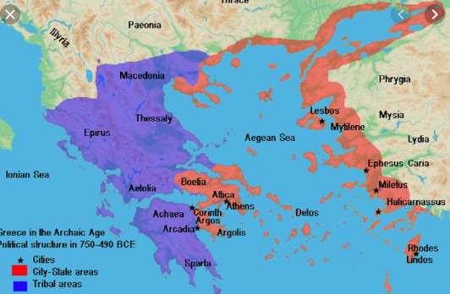

**Historical Enquiry:**

* **Examine sources about the past – including those about Ancient Greek economy, culture, beliefs and daily life.**
* **Describe how Greek life has impacted on society today.**
* **Explore the timeline of Ancient Greece and explain key features – where? Why?Who? How?**
* **Compare what was happening in the time of the Ancient Greeks with what was happening in Britain.**
* **Compare the Ancient Greeks with the Ancient Mayans and The Ancient Egyptians using historical evidence.**
* **Describe the difference between literal and inferential sources of information.**

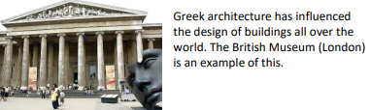

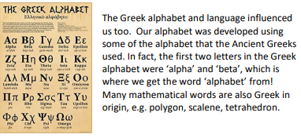

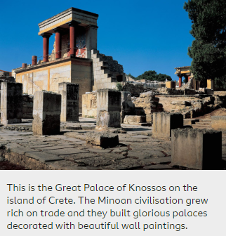

|  |  |
| --- | --- |
| **Vocabulary:** |  |
| Democracy | a system of government, where the population gets to vote for representatives that will represent their area. |
| Myth | a traditional story, especially one explaining the early history of a people or explaining a natural or social phenomenon, and typically involving supernatural beings or events. |
| Architecture | the art or practice of designing and constructing buildings. |
| Philosophy | study of the fundamental nature of knowledge, reality, and existence |
| Artefact | In archaeology, artefacts are the material remains of past human life and activities. |
| Legacy | Something left or handed down by a predecessor. |
| Examine | inspect (someone or something) thoroughly. |
| Analysis | a detailed examination of anything complex in order to understand its nature or to determine its essential features. |
| Evaluate | to judge the quality, importance, amount, or value of someone or something |

|  |  |
| --- | --- |
| Significant People in Ancient Greece: | * **Homer**, an important Greek writer, told stories of the Mycenaean age in his books **The Iliad** and **The Odyssey.** * Socrates (429-327BC) tried to answer questions such as: What is the right thing to do? * Plato (429-327BC) founded the world’s first university. * Aristotle (382-322BC) wrote books about physics, poetry, zoology, biology, politics and governments. * Architecture and art work around the world has many Greek origins. (Investigate) |

**Timeline of Significant Events** 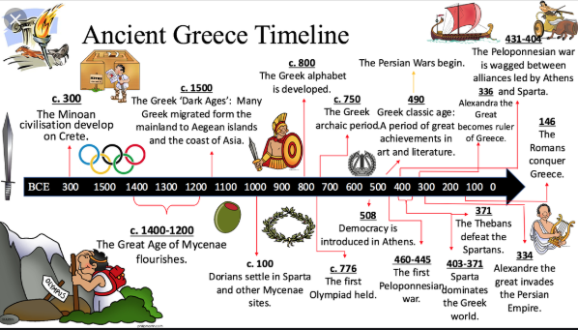

**Trips/ Visits & Useful Websites:**

<https://www.bbc.co.uk/bitesize/articles/zxytpv4>

<https://www.mysteriesintime.co.uk/ancient-greece-for-kids>

<http://www.primaryhomeworkhelp.co.uk/Greece.html>