MANCHESTER ROAD PRIMARY ACADEMY - HISTORY
Unit: The Great Fire of London | Year 2 | Strand: Significant Events from beyond living memory
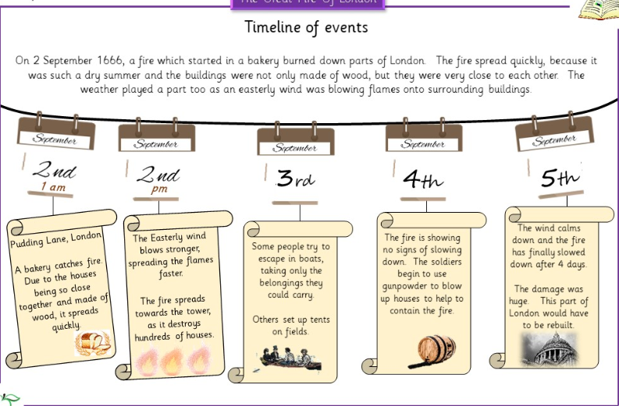
Useful Websites and Visits:
https://www.nationalarchives.gov.uk/education/sessions/great-fire/
https://www.mola.org.uk/blog/discovering-archaeology-great-fire-london
https://www.historic-uk.com/HistoryMagazine/DestinationsUK/Survivors-of-the-Great-Fire-of-London/
https://www.bbc.co.uk/programmes/p03xxm98/p03xxnnn

Historical Enquiry:
- Investigating types of evidence.
- http://www.fireoflondon.org.uk/browse-the-collection/
- Why are there no photographs or videos showing the event?
- How would this be prevented today?

What will be taught through the unit:
- About the evidence available that tells us about what happened during the fire.
- About the impact the fire had on people’s lives at the time.
- About how things changed after the fire so that it would never happen again.
Evidence from the great fire of London | - There are many types of evidence that let us know the Great Fire of London happened:  - King Charles II’s declaration to the people  - The diary of Samuel Pepys,  - paintings  - tax returns  - council acts  - eye – witness accounts  - objects/artefacts recovered from the fire.  - Children can compare those artefacts that are factual, and those that would be formed from opinion.
What was the fire? | - The fire began on 2nd September 1666 and was one of the largest disasters in British history.  - It lasted 5 days, and destroyed almost a third of London.  - The fire started at Thomas Farriner’s bakery on pudding lane, and spread fast due to several factors:  - The amount of fuel that was kept in the local area  - The proximity of the buildings in the area  - The material the buildings were constructed of.  - Narrow streets  - A strong wind.  - No organised fire brigade – the people had to use leather buckets, fire hooks and gun powder to break the fires.
What was the impact of the fire? | - People had to evacuate their homes and leave everything behind.  - There was no fire brigade in 1666, so the army had to help to put the fire out with buckets and hoses.  - Many people ran to the river to put their belongings on boats to escape. Some people ran to the countryside.  - 13,200 houses were destroyed and 87 churches.
After the fire | - After the fire planners spent a lot of time deciding how to re – build the city.  - They built less houses, and kept them further apart from each other.  - They designed the streets differently.  - The buildings were made from different materials and had to have a brick facing instead of wood.  - The changes from the time can been seen clearly when looking at before and after paintings.

