**MANCHESTER ROAD PRIMARY ACADEMY - HISTORY**

|  |  |  |
| --- | --- | --- |
| **Unit: Stone Age to Iron Age** | **Year 3** | **Strand: British History** |

|  |  |
| --- | --- |
| **What will be taught through the unit:**   * **The before records began in the Roman times, people had lived in Britain.** * **That society developed from hunter – gatherers to builders and technology developers to a tribal kingdom with tribes, farms and settlements.** | |
| How do we know about the civilisations in pre – historic Britain? | * There are many sites around Britain which have been excavated to reveal important artefacts from pre – historic Britain. * No written records were found before the Roman times, so what we know is from archaeological finds. * When people died, they were buried with their most important possessions. Many of these burial objects have now been discovered and they help historians to know more about what life was like during the Bronze Age. |
| The significant events in the timeline: | * **The Stone Age is split into 3 periods:** * **In the early Stone Age, which we call the Paleolithic,** people were hunters and they found food by roaming from place to place in different seasons. * The Paleolithic period lasts so long that it accounts for 99% of human history. * Art and religion began during this period. (Cheuvet in France/ Venus figurines) * **The middle Stone Age, called the Mesolithic**, began at a time when sea levels rose and Britain became an island (before this time Britain was joined to the mainland of Europe). During the Mesolithic period, tools were developed to become smaller and finer. The invention of canoes meant that people were better able to hunt for fish as well as animals. * **In the late Stone Age, which is called the Neolithic**, the way people lived changed a lot because they began to settle into farming villages instead of moving from place to place. People started to look after animals and grow their own crops. * **When people discovered how to get metals out of rocks, a metal called bronze replaced stone as the best material for making tools. This was the start of the Bronze Age.** * Bronze was made using a special process called ‘smelting’. People were able to build better farming equipment and they also began to make bronze weapons and jewellery * **In the Iron Age, a metal called iron replaced bronze as the main material for making tools and weapons:** * In the Iron age People lived in tribes and they were often at war with each other. * Because of all of the wars, Iron Age people began to protect themselves by settling in hillforts, which were groups of round houses and farming land protected by stone walls. * Sometimes people from the Iron Age are called ‘Celts’. This period of history ended when the Romans invaded Britain in AD 43. |

**Historical Enquiry:**

* **Children need to look at evidence found at different sites across the UK and think about what artefacts can tell us about the past.**
* **Children enquire as to Why? When? What? – especially regarding changes in human behaviour over time.**
* **An in – depth study into archaeological finds will allow children to think about what the way of life would have felt like.**

STUDY OF SKARA BRAE:

Skara Brae is a Neolithic Village in the Orkneys, Scotland.

It was discovered in 1850, when a storm battered the land and revealed the stone – age buildings and artefacts.

A lot of information about daily life can be gathered from Skara Brae:

* The people build furniture and storage
* They had fires and fire places
* They had made drainage around the village
* They made grooved ware pottery
* They kept animals and also ate fish (bones were found)

**Trips/ Visits & Useful Websites:**

<https://www.britishmuseum.org/PDF/visit-resource_prehistoric-britain-KS2.pdf>

<https://www.theschoolrun.com/homework-help/the-stone-age>

**Timeline of Significant Events:**

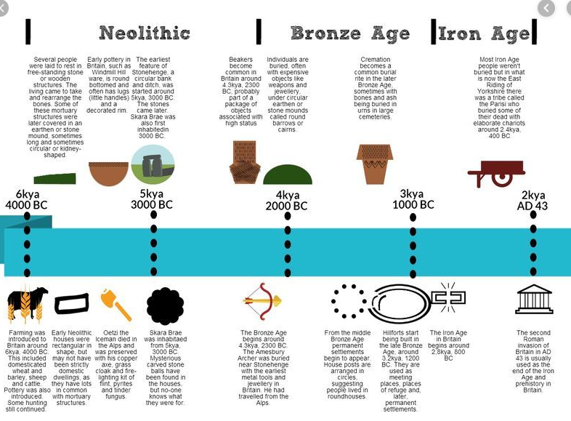

|  |  |
| --- | --- |
| **Vocabulary:** |  |
| Stone Age | The stone age is the name given to the earliest period of human culture when stone tools were first used. |
| Bronze Age | The bronze age is the time period when bronze replaced stone as the preferred materials for making tools and weapons. |
| Iron Age | The iron age is the time period when iron became the preferred choice of metal for making tools. |
| Neolithic | The neolithic is the youngest part of the Stone Age. The word "neolithic" comes from two words in Greek: "neo", meaning "new" and "lithic", meaning "stone". The neolithic period is the time when farming was invented and when people started caring for animals, such as cows, sheep and pigs. |
| Forage | To look widely for nourishment or other provisions. |
| Thatched | A thatched house or a house with a thatched roof has a roof made of straw or reeds. |
| Pre - Historic | Prehistoric means the time be- fore recorded history. |
| Monument | A group of huge stones, often set up in a line or circle |
| Tribe | Iron age people who lived in the same area and did similar things. |

