MANCHESTER ROAD PRIMARY ACADEMY - HISTORY
Unit: The Battle of Britain | Year 6 | Strand: Aspects of British history beyond 1066

What will be taught through the unit:
- That the battle of Britain was a significant turning point in the history of Great Britain.
- That we know lots of facts about this period in time due to an abundance of evidence sources.
- That Britain has been invaded many times over hundreds of years – This was the last time.
Facts about World War II and the battle of Britain. | - It began on 3rd September 1939 when Germany invaded Poland. Hitler said it was to give the German people more living space.  - The German army had already invaded many countries in Europe, and the only country left was Britain.  - In order to defeat the armed forces in Britain, Germany launched an attack on its air forces in the hope that it would make the defences weaker.  - This attack became known as the Battle of Britain and lasted from 10th July 1940 until 31st October 1940  - The British airforce are called the RAF and the German airforce are called the Luftwaffe.  - Both air forces had different strategies to try and win the battle. The British forces were outnumbered by the German forces.  - The night bombings made on Britain during this time overlapped with a period of time known as the blitz (7/9/40 – 11/5/41). The Germans do not agree with this – they believe it was one campaign lasting the whole period.  - Hitler was convinced they would win this battle, and that Britain would give up – or surrender. It is regarded as a major turning point in the war – and in Britain’s history.  - The battle of Britain takes its name from the speech given in the house of commons by Winston Churchill called ‘This was their finest hour’
Evacuation | - The evacuation of children, old people pregnant women, women with children under 5 and some of those who were disabled began.  - They were evacuated to avoid being harmed in the battles which were mainly in cities.  - Many went to stay in the countryside with relatives or friends. Some went to stay with strangers.  - Billeting officers were responsible for homing evacuees. People who took evacuees were paid by the government.  - Over 3.5 million people were evacuated during WW2.  - Some wealthy people evacuated themselves to other countries such as New Zealand, Canada and South Africa.

Historical Enquiry:
- Sources of evidence around events in the war differ significantly depending on what sources are used.
- The impact of the war is very much reported from the British point of view – what was the impact on the Germany people and society?
- What impact did the press have on the people’s attitudes towards the war?
- What things have been put in place around the world since WW2 to ensure it doesn’t happen again?

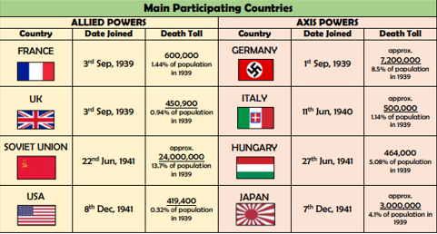

The Holocaust | - Hitler believed that everyone in Germany should look and be a certain way. If they did not fit this, he ordered them to be killed.  - During the Holocaust, over 6 million Jewish people were killed.  - The diary of Anne Frank is a significant piece of literature which gives an insight into what life was like for the Jewish people living in German – occupied countries.  - The evidence that the holocaust happened is clear – but some people still deny it ever happened.
Rationing | - Rationing was introduced because the supply of food from other countries was cut off due to ships being destroyed and shipping channels being blocked.  - Hitler thought this was a way of making the people of Britain weak.  - There were different types of rationing books, which limited certain foods – sugar, dairy products, eggs, cereals and meat.  - Rationing lasted for 14 years and ended in 1954.
The end of the war.  D - Day | - 6th June 1944 – the Normandy landings took place, which signified a turning point in the allies battle against the axis powers.  - The mission was code named operation overlord.  - On the first day 150,000 troops landed in France. By June 17th, there were half a million.  - They pushed back the German forces out of France.  - On 8th May 1945, Germany surrendered unconditionally. The war still continued in Japan until Nuclear bombs were dropped on Hiroshima and Nagasaki on 15th August 1945.
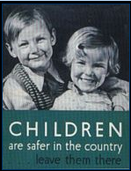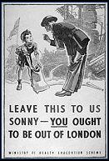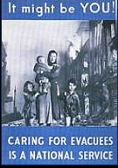
Posters about evacuation
People to study:
Winston Chrchill
Adolf Hitler
Franklin D Roosevelt
Neville Chamberlain
Vocabulary:
Axis powers | The countries who fought against the Allies – they wanted more land and power.
Allies powers | The countries who fought against the Axis.
Blitz | The bombing attacks in GB by the Germans
Evacuee | A person sent to the countryside for safety
Rationing | Food and other supplies that were rationed meaning you could only have a certain amount using tokens in a ration book.
Refugee | Men, women and children who were forced from their homes in German territory.
Invasion | Forcefully taking over another country.
Chancellor | The person in charge
Homeguard | The volunteers who defended the five thousand miles of British coastline.
The holocaust | The persecution and murder of 6 million Jews by the Nazi regime.

Trips/ Visits & Useful Websites:
https://www.ducksters.com/history/world_war_ii/battle_of_britain.php

http://www.primaryhomeworkhelp.co.uk/war/evacuation1.html#2

Timeline of Significant Events:
