MANCHESTER ROAD PRIMARY ACADEMY - HISTORY
Unit: Changes in Britain Through time: The Romans | Year 4 | Strand: Changes In Britain Through Time

What will be taught through the unit:
- About Julias Caesar and his attempted invasion
- The invasion by Cladius and Hadrian’s wall
- The British resistance – including Boudica
- How the Romans impacted on life in Britain: religion, technology, architecture, culture
The beginning of the Roman Empire | - As legend has it, Rome was founded in 753 B.C. by Romulus and Remus, twin sons of Mars, the god of war. Left to drown in a basket on the Tiber by a king of nearby Alba Longa and rescued by a she-wolf, the twins lived to defeat that king and found their own city on the river’s banks in 753 B.C. After killing his brother, Romulus became the first king of Rome, which is named after him.  - Rome expanded very quickly, built up a huge army and began invading nearby countries in Europe and North Africa.
The significant events in the timeline: | - (See Timeline)
Why the Romans invaded Britain | - There were 3 attempts made to invade Britain. Julias Caesar in bc55 and again he tried with a larger army a year later. Both failed. 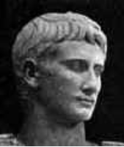  - In BC43 Emperor Claudius invaded and was successful. This is because some Britains in the South had started trading, and had made allies with the Romans. 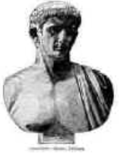  - The Romans wanted to expand their growing empire – they had already invaded most of Europe.  - They believed Britain was full of minerals and valuable agricultural land.
Boudica | - At the time of the Roman invasion, Britain was split into areas and had tribes. Boudica was the wife of the Iceni tribe who were in what is now East Anglia.  - Upon invasion the Romans only occupied the south of Britain.  - When her husband died, the Romans took the opportunity to invade the rest of Britain but Boudica set up and led an army to defeat them.  - The army was successful for a period of time and won many battles – but the Romans eventually outnumbered the Britons and invaded the majority of the British Isles.  - There are many versions of events surrounding Boudica – it depends which historians and materials are investigated. There are different spellings of her name, different versions of the battles, different descriptions of how she looked and different ideas about her death.

Historical Enquiry:
- Examine sources about the past – including those about Roman economy, culture, beliefs and daily life.
- Describe how Roman invasions have impacted on society today.
- Explore the timeline of Rome, and make links with other civilisations in the past – The Greeks, Egyptians and Mayans
- Discuss what was happening in Britain at the time of Roman invasion.
- Describe the difference between literal and inferential sources of information.
- Discuss and explore how different accounts of events in the past can occur.

A map of The Roman Empire at its peak.
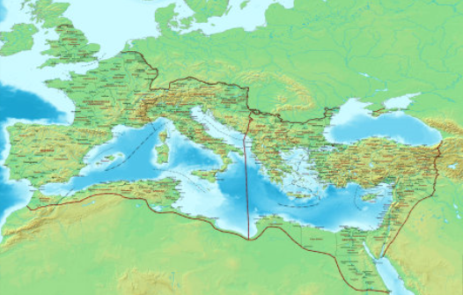

How ‘Roman’ is Britain now? | - Romans spoke Latin – which influenced many languages today – including French, Italian, Spanish and Portugese.  - The modern western alphabet derives from Roman times, and the calendar.  - Their culture of leading a people and joining together as one country.  - Christianity was brought to Britain during Roman rule.  - Many buildings and architecture – including roads and forts. Many towns and cities in Britain originate from Roman times.
The Roman Armies | - As the empire expanded, so did the army. The Romans needed a huge army to defeat the tribes living in Britain.  - To be in the army, you had to be male, and over 20.  - They travelled on foot and on horses. The armies were split into ‘legions’ and solidiers were known as legionaries. The soldiers came from all over the empire – including Italy, Spain, Africa and France.  - The army was well organised and trained. They often fought in lines and some soldiers had specific tasks they would fulfil – including catapults, archers and horsemen.  - Roman soldiers had a specific armour and supply pack that they would carry for miles each day.
Roman Roads and Architecture in Britain today. | - There are many towns and cities in Britain that have Roman remains. This is how we know information about the Roman times and what life was like.  - Chester is a Roman city in the north of England:  - It is built around a Roman fort once called Deva.  - It has a huge military amphitheatre  - It is thought that Chester may have been the main place that Britain was governed due to how large the fortress was.  - There are the ruins of baths and gravestones from the Roman times in Chester.  - Roman roads were complex and far – reaching and many are still used today.  - They used concrete to lay foundations and built main roads between cities.  - They built roads to easily transport goods and the army in a quick way.
Vocabulary:
Rome | The capital city on the Tiber: ancient capital of the Roman empire
Emperor | The ruler of the Roman empire
Legion | A division of 3 – 6,000 men in the Roman army
Villa | A large country house of Roman time, consisting of a farm and residential buildings arranged around a courtyard.
Ampitheatre | An open circular or oval building with a central space surrounded by tiers of seats for spectators, for the presentation of dramatic or sporting events.
Chariot | A two – wheeled vehicle drawn by horses, used in ancient races and warfare
temple | A building devoted to the worship of gods
bath | A building containing rooms designed for bathing and relaxing and socialising, as used in ancient Rome.
invasion | One country attacking another to take it over
Artefact
evidence

Trips/ Visits & Useful Websites:
https://www.bbc.co.uk/bitesize/topics/zqtf34j
https://www.bbc.co.uk/bitesize/topics/zqtf34j/articles/ztqg4wx
primaryfacts.com

Timeline of Significant Events:
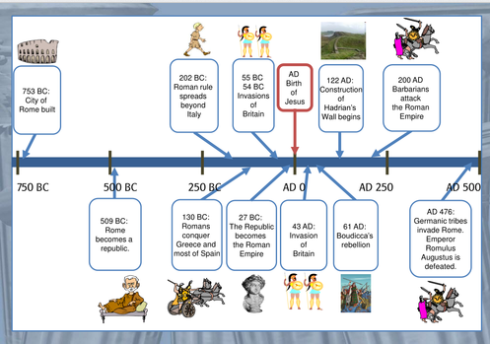

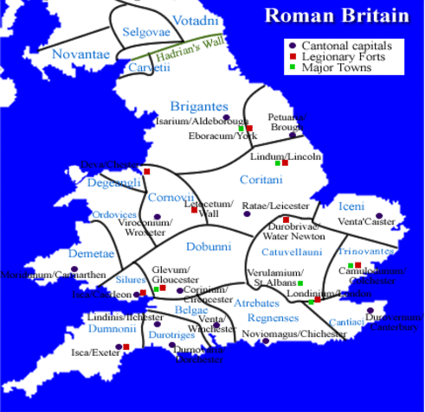
A map of Roman Britain

