**MANCHESTER ROAD PRIMARY ACADEMY - HISTORY**

|  |  |  |
| --- | --- | --- |
| **Unit: Titanic** | **Year 2** | **Strand: Significant Events in history.** |

|  |  |
| --- | --- |
| **What will be taught through the unit:**   * **That there are significant events in time which impact on life today.** * **That significant events in time are remembered and anniversaries commemorated.** | |
| What was the Titanic? | * **The Titanic was built by the White Star Line and was, at the time, the worlds biggest passenger liner.** * **Construction of the Titanic began on 31st March 1909, and it took 3 years to build.** * **The Titanic was 269 meters long and weighed 52,310 tonnes.** * **In 1911, the Titanic was declared unsinkable, and was said to be a marvel of British engineering.** * **It cost 3.25 million pounds to build the Titanic.** * **There were 9 decks on the titanic.** * **The maiden voyage set off on 1`9th April 1912.** * **The ship was named the RMS Titanic (RMS means Royal Mail Ship)** |
| Who boarded the titanic and why? | * Some people were heading to America to do business. * Some were travelling for a holiday. * Some were heading to America to make a new life for themselves. * Anyone travelling on a ship was maned in the local papers on a list. This was seen as quite a priveledge! * First class passengers were on the top deck of the ship. They had the best views. These were business people. Second class passengers were those who were going on holiday., and immigrants who were heading to America for a new life were the poorest, and so had their rooms below deck in 3rd class. * The laws on ships at the time were that the classes of passengers could not mix. |
| What happened on the Titanic? | * The Titanic set off from Southampton on 10th April 1912.It stopped in France to pick up passengers, and then headed to Queenstown in Ireland to pick up more. * It set sail across the Atlantic on 11th April 1912. * The ship was said to be indestructible, but the engineers hadn’t considered what would happen if an iceberg hit the side. * The captain was given warning from the crew, but he chose to ignore it until it was too late. When he tried to steer clear, the ship hit the iceberg. * There were suppose dot be 32 lifeboats on board, but there were only 20. Some of the lifeboats were only half full when they were set sail. * The Titanic sank at 2.20am on April 15th 1912. * Over 1500 people died. 700 survived – mainly women and children. |

**Historical Enquiry:**

* **How do 1st person accounts differ from those published by papers?**
* **What did engineers learn from the sinking of the Titanic?**
* **Were 3rd class passengers treated differently when the ship was being evacuated?**
* **There are many ‘theories’ made by people as to why the Titanic sank.**

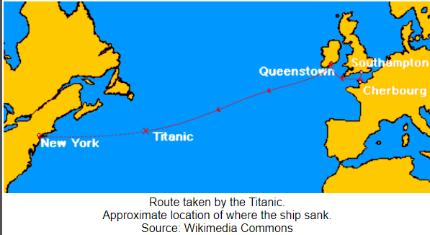

|  |  |
| --- | --- |
| How do we know about the events on the Titanic? | * Evidence from the evening takes many forms: * Photographs from passengers * Letters written ready to be sent home * Passenger lists * Ships records * Evidence given after the sinking from passengers – eye witness accounts. |
| Exploring the wreckage | * There have been many expeditions to the Titanic below the sea. Radars found the wreckage in 1985. * There are many items on display from the ship in museums in America and Britian. |



|  |  |
| --- | --- |
| Titanic | RMS Titanic – the name of a luxury liner that was the largest man – made moveable object ever built at the time. |
| White Star Line | The company that owned the Titanic |
| Southampton | A city in the UK from where the Titanic set sail. |
| New York | A city in the USA where the Titanic was heading |
| Belfast | A City in Ireland where the Titanic was built. |
| Atlantic Ocean | The ocean between the UK and USA |
| Iceberg | A large piece of floating ice, most of which is under the water |
| Maiden Voyage | The fist journey of a new ship after it has been completed. |
| class | The social order of people. On the titanic there was 1st, 2nd and 3rd class |
| Morse code | A series of dots and dashes used to send messages over wireless telegraph. |
|  |  |

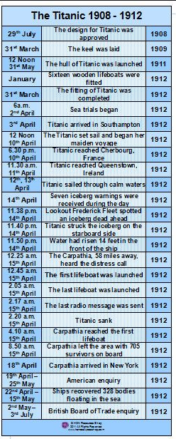

**Vocabulary:**