MANCHESTER ROAD PRIMARY ACADEMY - HISTORY
Unit: Victorian Toys and Children’s lives | Year 1 | Strand: Changes within living memory

What will be taught through the unit:
- That things change over time.
- We talk about time using past, present and future.
- There are things from the past – like toys, that older people will remember.
Rulers of the past: | - There have been many rulers of England and Great Britain over time. This is called the Monarchy.  - Most people alive today will only remember our current Queen, Queen Elizabeth the II, Her father King George VI, and Maybe Edward the VIII.  - Before these Monarchs was Queen Victoria, and we call the time she was the ruler the ‘Victorian Times’  - We still have a monarchy, but we also have a parliament who make most decisions about our country today – in the Victorian times, the Queen would have made a lot of decisions herself.
Toys were different in the past to how they are today: | Toys Victorian children would play with:  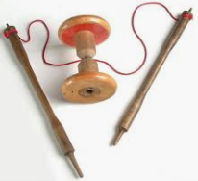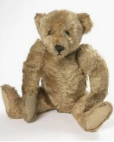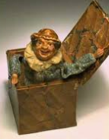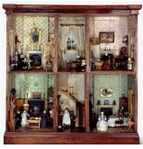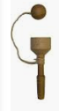  - These were made mainly of wood, metal and fabric, which would be made in mills and factories.  - Victorian children would play outside most of the time because their houses were small, and had lots of people living in them.  Toys that parents and Grandparents would play with:  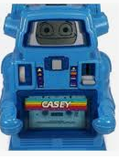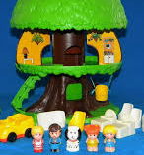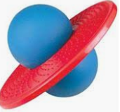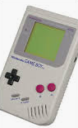  - These were made mainly of plastic and rubber.  - Some electronic games were invented.  - Some toys were made in different countries and brought to Britain by ship.

Kings and Queens of Britain:
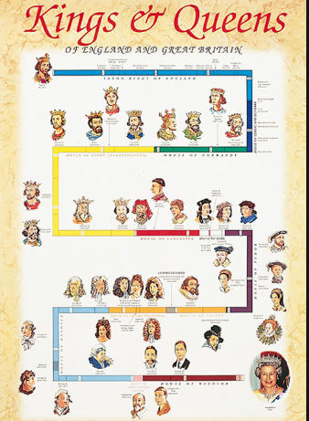

Historical Enquiry:
- Look at what Britain was like before Queen Victoria using images and compare this with after the Industrial revolution – what do children notice?
- What do different sources of evidence tell us? Are all black and white photos from the past?
- What toys did parents and grandparents play with? What were their favourite toys?
- Can children group toys from now and from the past?

Since Queen Victoria there have been 5 monarchs:
Edward VII
George V
Edward VIII
George VI
And
Elizabeth II

Toys that children play with today:
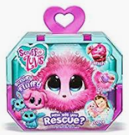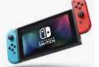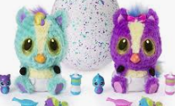
- More electric/ battery operated toys
- Lots of different materials – especially man made materials
- Many toys now made in other countries.

- Children need to talk about the fact we can still get toys from the past now… dolls, books etc… but they could not get the toys today due to technology, inventions and travel.
What life was like for children in Victorian Britain: | - There was a stark difference between the lifestyle of children who were rich and poor in Victorian times: clothes, food, houses, toys, lifestyle (school etc…)  - Some Victorian children went to work because there was so much work to do in the mills, mines and factories that there weren’t enough adults to do all the jobs, so children often worked in these roles.  - If children went to school, it was part time and then they would go to work afterwards.  - Inside the home, girls would complete the household chores – for their own families and for others to earn money.
How Britain changed in the Victorian times: | - Before Queen Victoria, people lived in villages and worked from home.  - The industrial revolution saw a huge rise in towns and cities, buildings and there were lots more people.  - Transport was invented – including the canals, railways and the development of the motor car – before this, horses were used to move things around.  - People started to go on holiday more – especially to the seaside such as Blackpool, Morcambe, Southport (Northern seaside resorts)  - More homes were built, and these looked very different from the cottages which filled the landscape before the Victorian era – children can identify Victorian homes locally.
Looking at Evidence | - There is a wealth of evidence from the Victorian times – children look at photos, census records, letters, buildings. What do these things tell us?  - Objects from the past need to be treated with respect – they cannot be replaced.
An Example of how products can change over time:
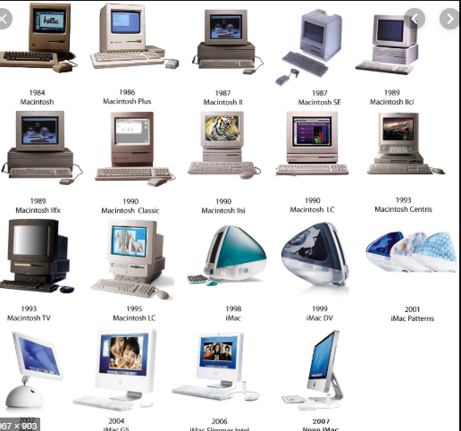
Vocabulary:
Past | Things that have happened in time before.
Present | Things that are happening now.
Evidence | Things that tell us what life was like in the past.
Artefacts | Things that we can find to tell us about the past.
History | A study of the past.
Modern | Relating to present or recent times.
Machine | Something that uses mechanical power to work.

Children will also use the vocabulary from science to describe the materials and feel of the objects and toys.

Trips/ Visits & Useful Websites:
Visit Portland Basin
Pinterest has some great timelines of individual toy products – very interesting!

Timeline of Significant Events:
