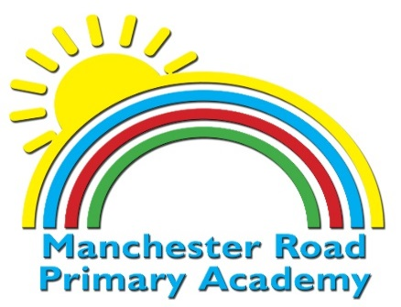

Midday Assistant

Salary Grade A – Scale Point 1 - £ £2131.58 pa £177.63 per month to Point 2 £2174.12pa £181.18 per month
5 Hours a Week – Term Time Only

Manchester Road Primary Academy is a popular two form entry primary school in Droylsden. It is a friendly school with a strong and caring ethos and as such we are seeking a positive, well motivated and friendly midday assistant to join our team.
We are looking for someone who :
- Has a positive and caring disposition
- Has an energetic approach to their work
- Is professional and a good team player
- Has good communication and interpersonal skills
- Has high expectations for all children and is committed to developing the children’s skills during the lunchtime period
The school is committed to safeguarding and promoting the welfare of children, young people and vulnerable adults and expects all staff and volunteers to share this commitment. This post requires an enhanced DBS disclosure to be obtained before commencement.
If you wish to apply for this post visit enquirelearningtrust.org and complete an on-line application and email the completed form to Jill Bate; School Business Manager, admin@mrpa.org.uk

Closing Date: 29.9.21
Interviews : 1.10.21

