**MANCHESTER ROAD PRIMARY ACADEMY – Religious Education**

|  |  |  |
| --- | --- | --- |
| **Unit: What does it like to be a Hindu in Britain today?** | **Year 4** | **Strand: Believing** |

|  |  |
| --- | --- |
| **What will be taught through the unit:**   * **To be able to discuss what Hindus have and do in their homes.** * **To describe some examples of how Hindus show their faith.** * **To explain similarities and differences between Hindu worship and worship in other religions.** | |
| Books and Stories: | * Hinduism has lots of stories and myths that explain why things happen in the world and why we should live life a certain way: * Rama and Sita * Vamana Avatar * The honest old man |
| Key Aspects: | * Hinduisms is a religion and a dharma (way of life). It is widely practised in the Indian subcontinent and parts of South East Asia. * Brahman and atman are vital concepts of the Hindu understanding of a human being.   - The atman is the person within, it is trapped in the physical body and wants to escape terrible dangers, but the human is distracted by the trivial pleasures instead of trying to get out.     * Hindus believe n the idea of Karma, and how actions bring good or bad karma – where in each life the person is rewarded or punished for the things that they have said or done in their last life. * Hindus hold beliefs about samsara, where the atman travels through various reincarnations, to achieve Moksha (liberation from the cycle of birth and rebirth/reincarnation.) Moksha is where a person can join the Gods. * The four aims of life for Hindus are: Dharma – Religious or moral duty, Artha – economic development, providing for family and society by honest means, beauty of life, Moksha – liberation from the cycle of birth and re birth/ reincarnation. * Hindus believe life is part of a journey through different stages (ashramas), each with different duties.      * Hindus believe that to be a good Hindu, they hold the value of ahisma (non – violence) and satya (truthfulness). These values were embedded in Mahatma Gandhi’s nonviolent campaign for India’s independence from British Rule. |

|  |  |
| --- | --- |
| **Vocabulary:** |  |
| Hinduism |  |
| Arti | A celebration of light |
| Brahman | The Hindu god that can take any form. |
| Brahmin | A Hindu priest |
| Dharma | A duty |
| Karma | The view that good deeds result in good benefits and bad deeds can lead to bad results. |
| Mandir | A temple where Hindus go to worship |
| Moksha | The highest goal in life for Hindus |
| Puja | A prayer or ritual offering flowers, light, food and water to the divine. |
| Reincarnation | The idea that when someone dies they are born again. |
| Samsara | The ever turning wheel of life |
| Trimurti | The 3 forms of god (Brahma, Vishnu and Shiva) |

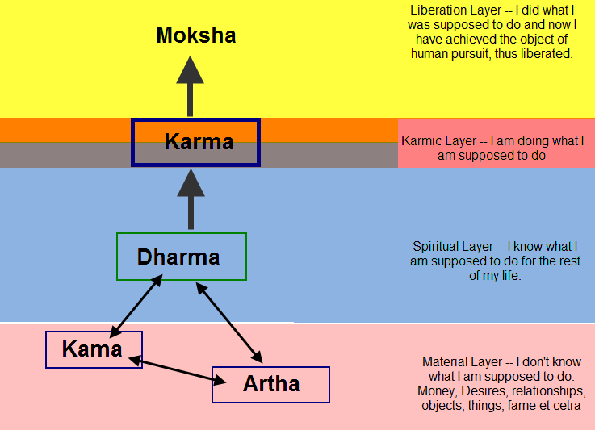

Key Celebrations:

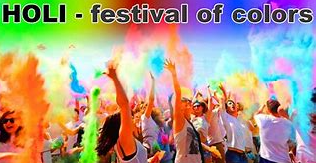 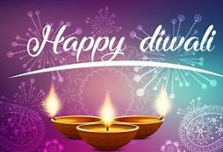 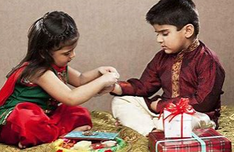

Holi festival celebrates the beginning of spring and is known as the festival of colours.

Raksha Bandhan is the festival of brothers and sisters; a celebration of the relationship between brothers and sistersand the dharma (duty) one has to their family.

Diwali is known as the festival of lights because houses and shops and public places are decorated in small oil lamps called diyas.

Useful Websites and Resources:

<https://www.hindujagruti.org/hinduism-for-kids/category/children-stories>

<http://www.primaryresources.co.uk/re/re_Hinduism.htm>

<https://www.bbc.co.uk/bitesize/topics/zh86n39/articles/zmpp92p>