**MANCHESTER ROAD PRIMARY ACADEMY – Religious Education**

|  |  |  |
| --- | --- | --- |
| **Unit: Who is a Muslim and what do they believe?** | **Year 2** | **Strand: Believing** |

|  |  |
| --- | --- |
| **Vocabulary:** |  |
| Prophet | A person regarded as an inspiring teacher or leader of the will of god. |
| Nasheed | Vocal chants sung with or without instruments |
| Islam | The religion of Muslims |
| Halal | Meat prepared to Muslim law |
| Haram | Forbidden by Islamic law |
| Qu’ran | Holy book of Islam |
|  |  |
|  |  |
|  |  |
|  |  |

|  |  |
| --- | --- |
| **What will be taught through the unit:**   * **The key aspects of the Islamic faith, including their belief in there being only one god.** * **To know that Muslims do not draw Allah or the Prophet Muhammad (PBUH)** | |
| Books and Stories: | * The Qu’Ran is the most important book to Muslims. Muslims believe that it contains the words of Allah. * The gift of sands and the sad camel are two stories which tell children about the life of the prophet Muhammad (PBUH) |
| Key Aspects: | * The Qu’ran was presented to the Prophet Muhammad (PBUH) on Mount Hira by the angel Jibril. * The key belief of Islam is that there is no other God but Allah and that Muhammad is the prophet of Allah. * A Nasheed is a chant or vocal music that is sung by Muslims. They often have words about the religion of Islam, about the past and about practices. Muslims do not draw images of Allah or the prophet Muhammad (PBUH). Instead they use calligraphy to say what god is like.:      * There are currently around 1.9 billlion Muslims around the world and around 3 million living in the UK. * Muslims believe in living life according to 5 pillars:   + - Shahada – there is only one God Allah with Muhammad (PBUH) as his messenger.     - Salat – prayer 5 times a day     - Zakat – giving a portion of salary to charity     - Sawm – Abstaining from food and drink during the month of Ramadan between dawn and nightfall.     - Hajj – making the trip to Mecca at least once in your lifetime. * The food Muslims can eat is called Halal, and the foods they cannot eat are Haram. * Muslims pray in a building called a mosque * Before prayer, Muslims take off their shoes and wash * Muslims can pray anywhere as long as it is respectful to Allah (clean and free from distractions) * Women can choose to wear a headscarf called a hijab or face covering called a niqab. Men may wear a cap called a topi. |

Symbols of Islam:

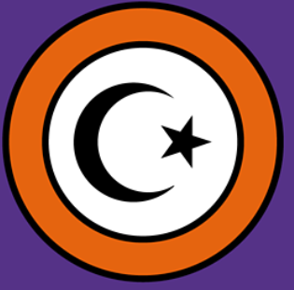 The star and crescent moon

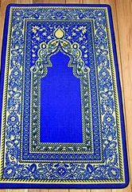 Example of a prayer mat.

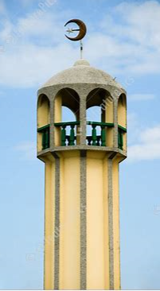 A minaret with the cresecent and star

**Trips/ Visits & Useful Websites: Trip to Ashton Mosque.**

<https://ayeina.com/islamic-story-a-day-ramadan/> - Stories for children